**This decade saw Sexey's change from a Grammar school to a Middle school - without doubt, the end of an era.**

**( Remember to check the top of the home-page to see if there have been any recent additions to this section.)**

**These undated newspaper articles show Mr Ravenscroft's thoughts during the early 1970's with the school employing a 2 form entry. Assuming this was done on a single 2 class entry per school year, the article's comment 'Sexey's have two forms in the first three years, he said' would put this article as being the Speech day of 1970 with the years in question being 1968, 1969 and 1970.**

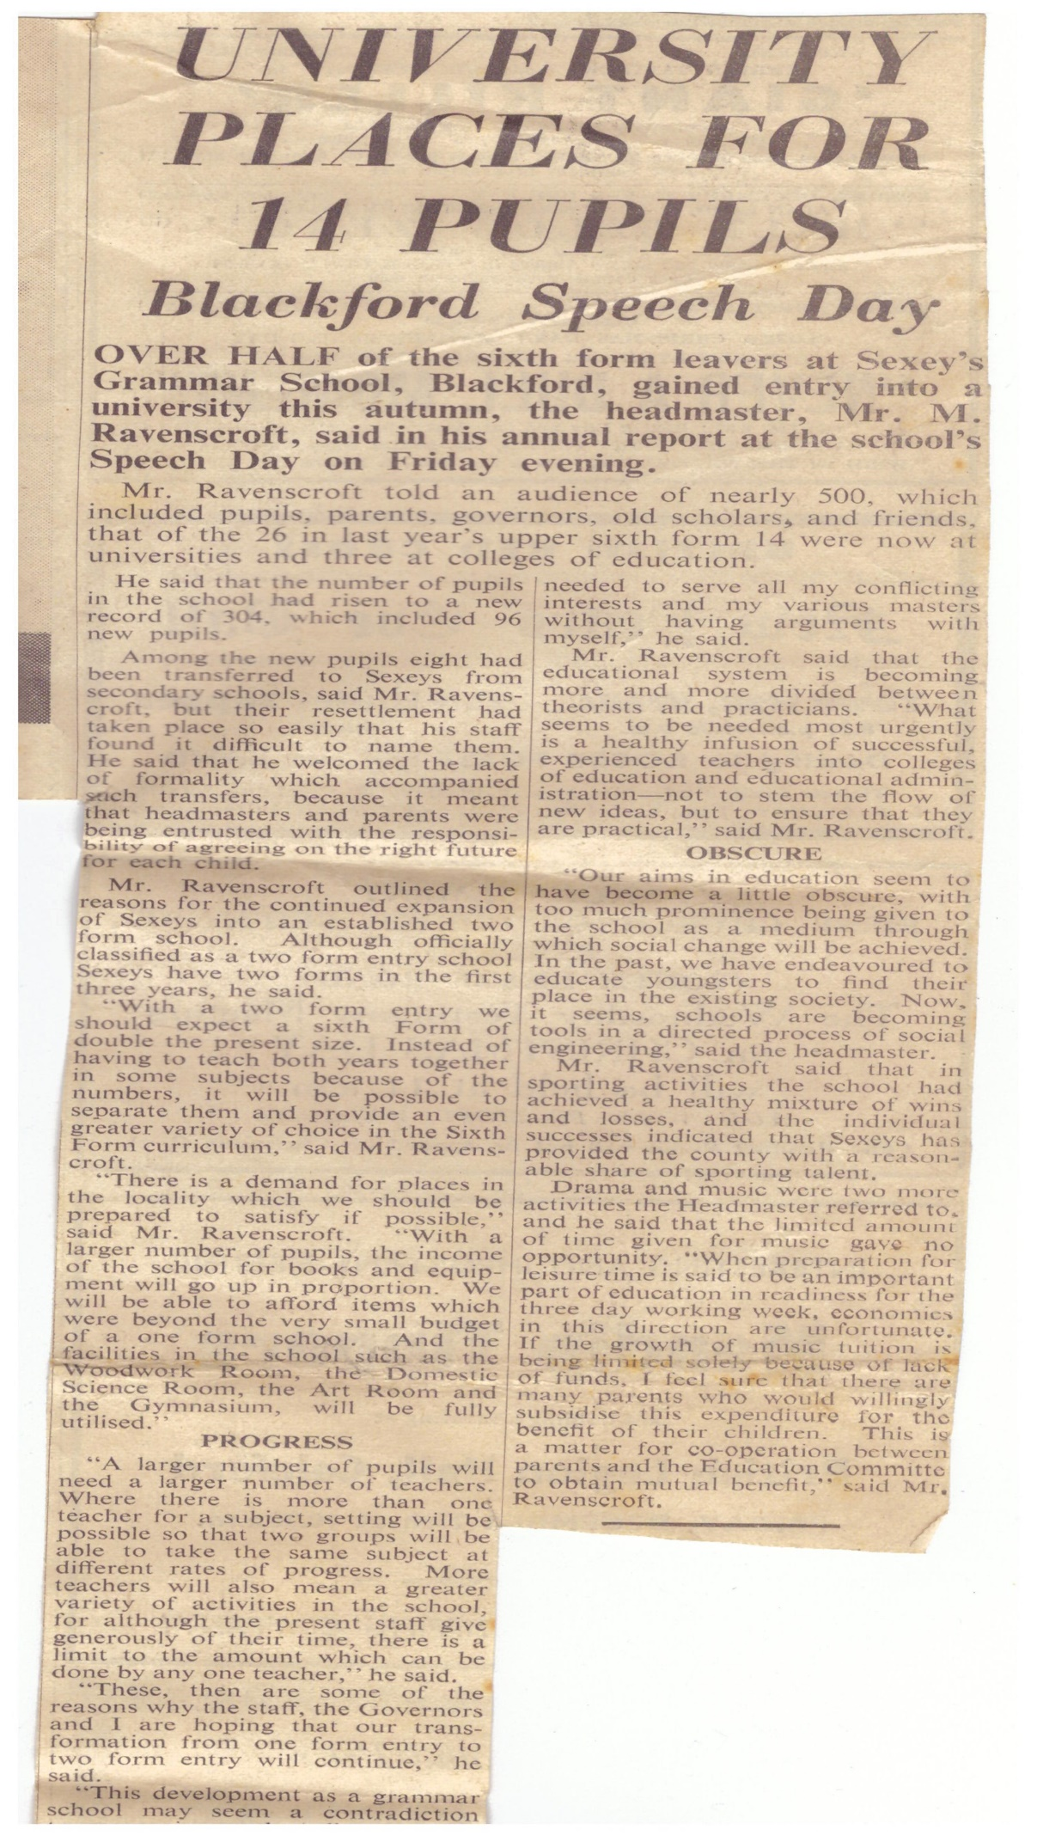

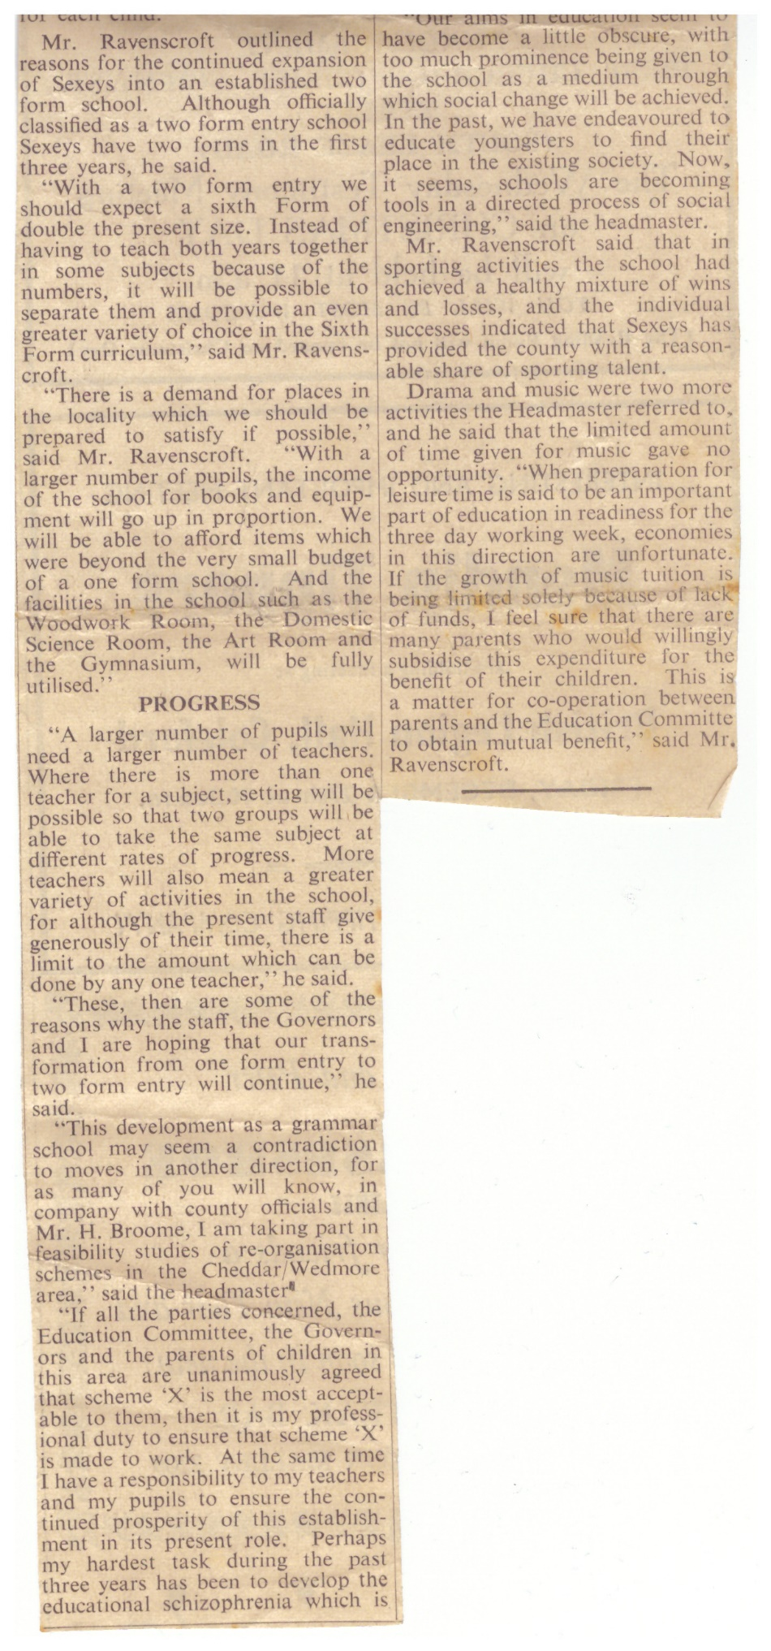

**(Many thanks to Pete Nicholson (Class of '63) for these articles and apologies from me for the slight overlapping of the texts - Martyn)**

**My own (Martyn James) memories of the 70's, only extend to the summer of '71, as this was my final year.**

**Having entered the 6th form, the big change for my year group was that we found ourselves with our own separate space within the school, in the form of the old hostel, (previously used by the female boarders until '66), which had become the 6th form block.**

**The hostel itself provided us with a number of rooms with lockers for books, comfortable chairs and even a record player ! - I can remember particularly liking 'Credence Clearwater Revival' and 'Free' then someone brought in something avant garde by 'Pink Floyd' and many of us got turned on to that ! ( never to listen to run of the mill 'pop' music again - well, at least for another 30 years! - I am now, and have been for many, many years a very keen 'Yes' fan but do enjoy the odd visit to see 'Jethro Tull'.)**

**The boys in particular, were very fortunate at this point. In the lower sixth we had an intake of quite a large number of  attractive girls from other schools in the area - I think a number of them came from Rossholme, and this meant a very agreeable boy/girl ratio from a male's point of view!**

**As you might expect, a number of serious, boy/girl friendships formed during this period and, sadly, like 99% of teenage relationships, most of them  came to nothing in the end (including mine!) simply leaving a number of distant memories, although one or two were *very* long lasting and meaningful.**

**One of those long lasting relationships, ended in two of my classmates, Tony Cousins and Lynda Weeks, marrying a few years after they'd left school -  I can still vouch that they are happily married! ( Tony and Lynda live a few hundred yards down the road from me and have given me many items for inclusion on the website - many thanks, you two.)**

**A mention should also go  to Andy Milne and Jayne Lukins, who have recently made contact. Both were class members who were 'going out' with one another in the sixth form. After 36 years or so, Andy and Jayne have recently renewed their friendship and are now 'a couple' again - best wishes to you both!**

**As well as members of the opposite sex becoming a great but very welcome distraction, it was around this time that some of us started driving, and cars came on the scene. There were quite a number of us that were very 'car minded' and started having driving lessons as soon as we were able.**

**In my year I was one of the first to pass my driving test ( I think Andy Milne might have just beaten me to it) and ended up 'sitting in' on a number of occasions, with some of my classmates as the 'full' driver (John Butt, Debbie Higgison, Geoff Thorne and Vicki Roseff are some that come to mind) - as far as I know they're all still with us so I must have done something right!**

**Occasionally, we would drive to school ( I think we had to ask permission first). Many of us drove Minis and a small section of tarmac at the front of the changing rooms was allotted for parking.**

**Quite a few of us tended to drive at silly speeds in those days (thank goodness the roads were quieter) and I can remember Andy Milne turning his blue Mini Van over on more than one occasion! ( Can you remember turning your white, Isetta bubble car over in Burnham, Andy?) I remember it very well as I was inside it at the time!! (My memory for these events obviously isn't quite as good as I'd first thought. Andy has made contact and tells me that it wasn't him that rolled a minivan but someone else - he also tells me it was his *red* bubble car that got turned over, his white one being in bits at the time!)**

**If my memory is correct, driving to school was stopped temporarily when one of the pupils - (Andy? - *apparently* not - all will be revealed when I find the school's log book for 1971!! - MJ ) ended up having an accident when he/she turned out of the school and was hit by a car. I don't *think* anyone suffered serious injury- can anyone add more details about this incident?**

**Clare Marwood (Costigan), who was in the year below mine, has recently written in to say that a similar accident happened in 1972 when she was in her final 6th form year -**

**'I was amused by your story about the car collision turning into the car  
park behind the gym. The same thing happened a year later in 1972 when a  
load of us went to the Watchfield Inn at lunchtime, to celebrate my 18th  
birthday. Andy Jackson collided with another car as he turned into the  
school gate. It wasn't serious but I had to plead to Mr Brooke for a  
merciful punishment for Andy. Mr Brooke was a real softie underneath  
that sometimes rather scary exterior and Andy escaped with a good  
telling off!' (Thanks for that, Clare - MJ)**

**With regards to 'day to day' friendships, the class as a whole, got on very well together, with a really broad mix of characters, talents and interests. The arrival of the new girls in the lower sixth gave the class a new dimension and was very successful, they mixed very well with the original class members, both male and female - there certainly didn't appear to be any 'bitchiness' between the old and the new girls (which could easily have happened in those circumstances), just as there was never (or very rarely) any real animosity amongst any of  the boys.**

**After 37 years, I still feel it was a very special class of pupils and I feel very lucky to have been part of it** **- a good example of where 'the whole is greater than the sum of its parts'. (I think I've just talked myself into organising a class reunion! - MJ)**

**Outside of school, many of us would mix together socially and I can remember some brilliant, all night parties that were either held in Vince Russett's garage at Hythe Bow,Cheddar (where far too much alcohol was readily consumed!) or at Vicky Roseff's - Vicky lived in a very large house in Burnham on Sea called 'The Towans' and the garage was ideal for loud, teenaged parties!**

**The 'regulars' at these parties would have been the likes of myself, Geoff Thorne, Vince Russett, Andy Milne, Vicky Roseff, Debbie Higgison, Jon Line, Lesley Pearse, Tim Arlidge, Alan Keen and many others. (Where did those easy-going, 'fun' days go?? - answers on a postcard to ........................)!**

**Fortunately, we weren't all 'dirty stop-outs'- five members of our class, all talented musicians, got together out of school for far more creative reasons than partying hard and formed a band who actually featured on 'Radio Bristol', no less!**

**The band consisted of, L-R - Anne Perry (Piano), John Butt (Trombone), Tony Cousins (Drums), Dennis Johnstone (Clarinet) and Margaret Chester (Double Bass).**

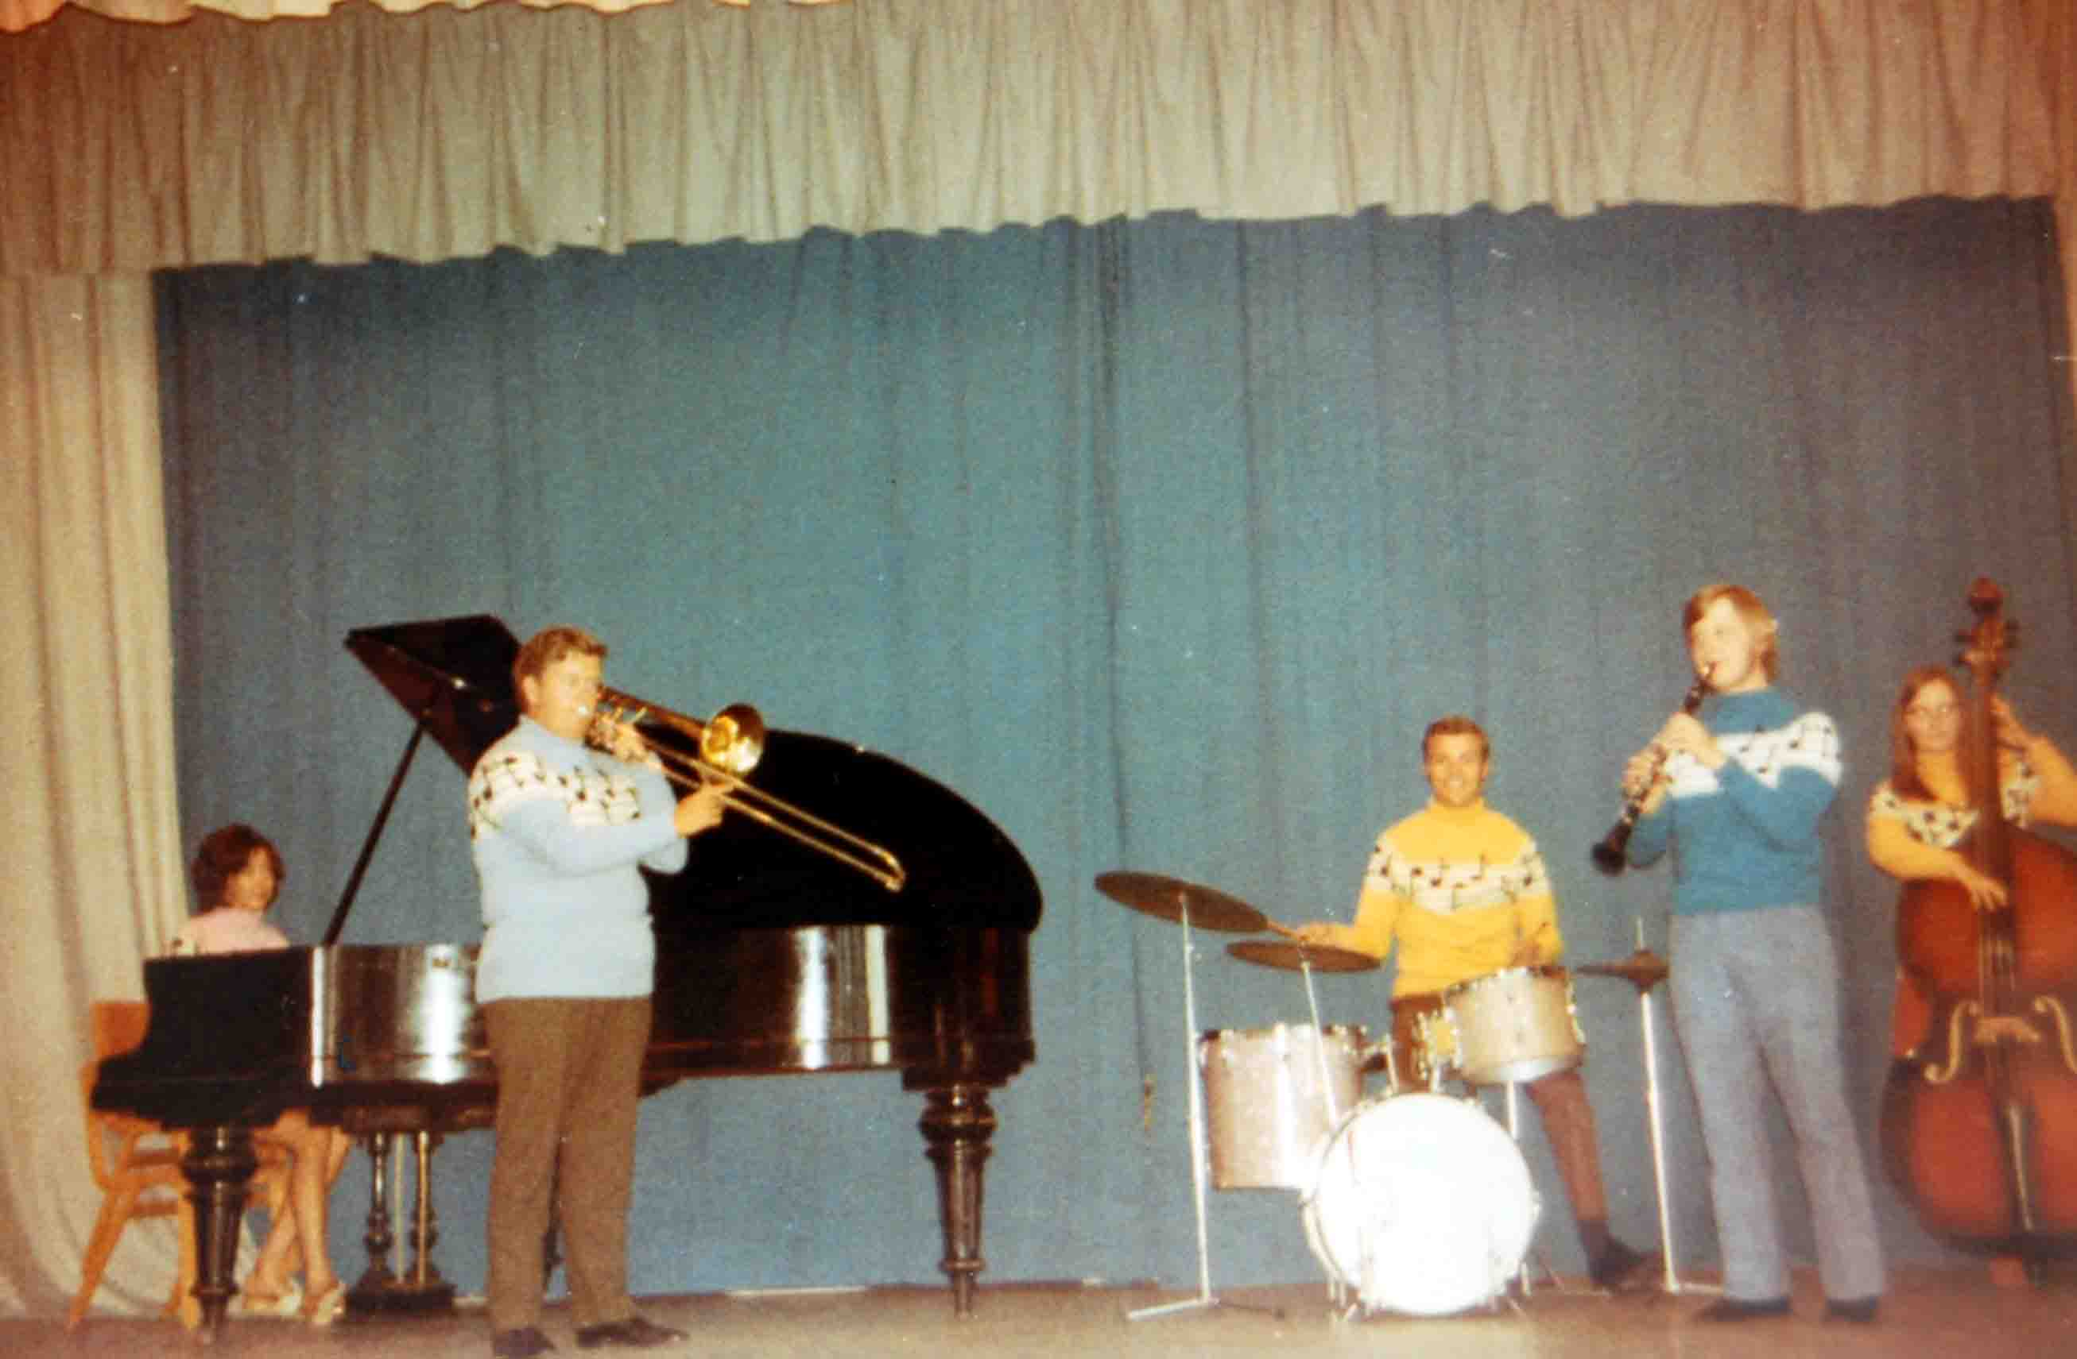

**Here,the five band members pose for a photo on the school stage.**

**They actually started the group in the late sixties (most of their 'story' comes from the early '70's, so I've included it here) and initially called themselves 'The Buttercups' -  ( I think John Butt must have had some input there!).**

**They eventually kitted themselves out in some very smart 'musical' jerseys. Fortunately, Tony still has his and here it is ( I'm not sure if it still fits, though! - MJ) - the musical notation on it can be clearly seen.**

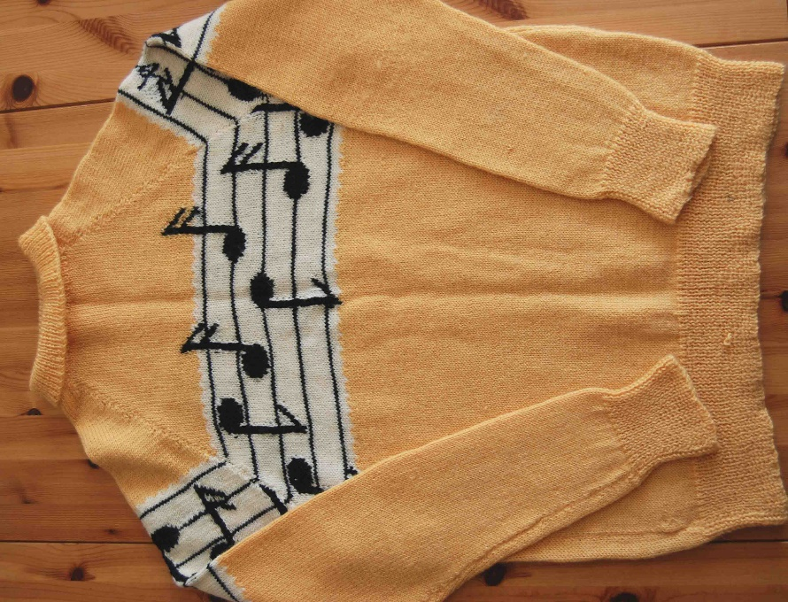

**The jerseys were knitted by Mrs Butt, who expertly knitted all five - a definite 'labour of love' - hats off to her! They were first used when the group entered the Highbridge Music festival, where they won their class.**

**Not only did the band now have a very fetching 'uniform' but Tony decided a 'Buttercups' logo was needed to go on the drum-kit. Here's the original prototype drawing that Tony has kept for all these years.**

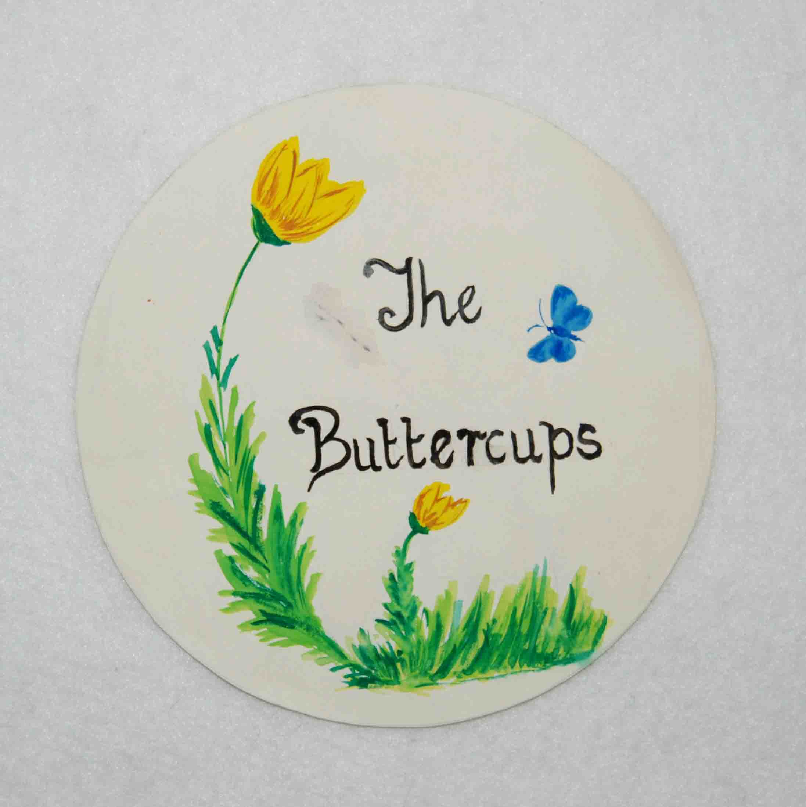

**'The Buttercups' name wasn't to last very long and** i**n February, 1969 they changed their name to 'The Saints'.**

**At some time in the early '70's the group played a gig on the Knightstone Pier, Weston super Mare and fortunately for them, Roger Bennett, a well known Radio Bristol presenter was there also. Roger obviously liked what he'd heard (I've been told that Roger really knew his stuff where music was concerned, so this was quite an honour.) and invited the group up to Radio Bristol for the day, so they could play (and be interviewed) live on air.**

**Their day at the studios was eventually broadcasted on October 14th, 1971. Tony still has the 'reel to reel' recording of the day which has now been digitised. The quality isn't brilliant but bear in mind that the original tape is around 37 years old!**

**(To turn the music off, click the 'X' in the small window that's opened - if it's gone, click its reference in the task bar (right at the bottom of the page) and then click 'X'.  Clicking the Jukebox button will simply restart the music!)**

**The following three photos were taken at the Radio Bristol studios and shows, in order, Tony, Anne and Dennis 'strutting their stuff'.**

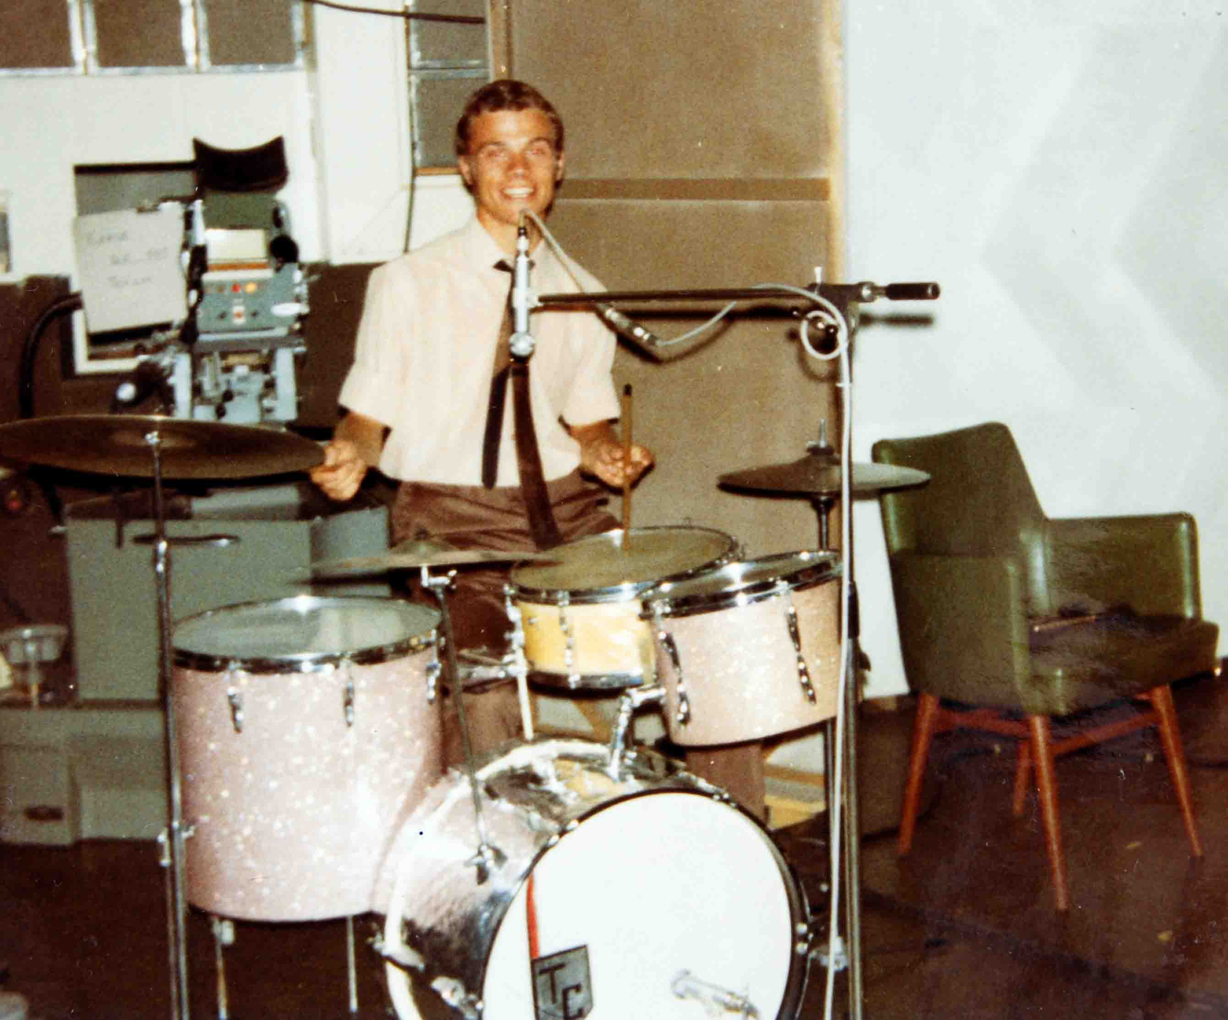

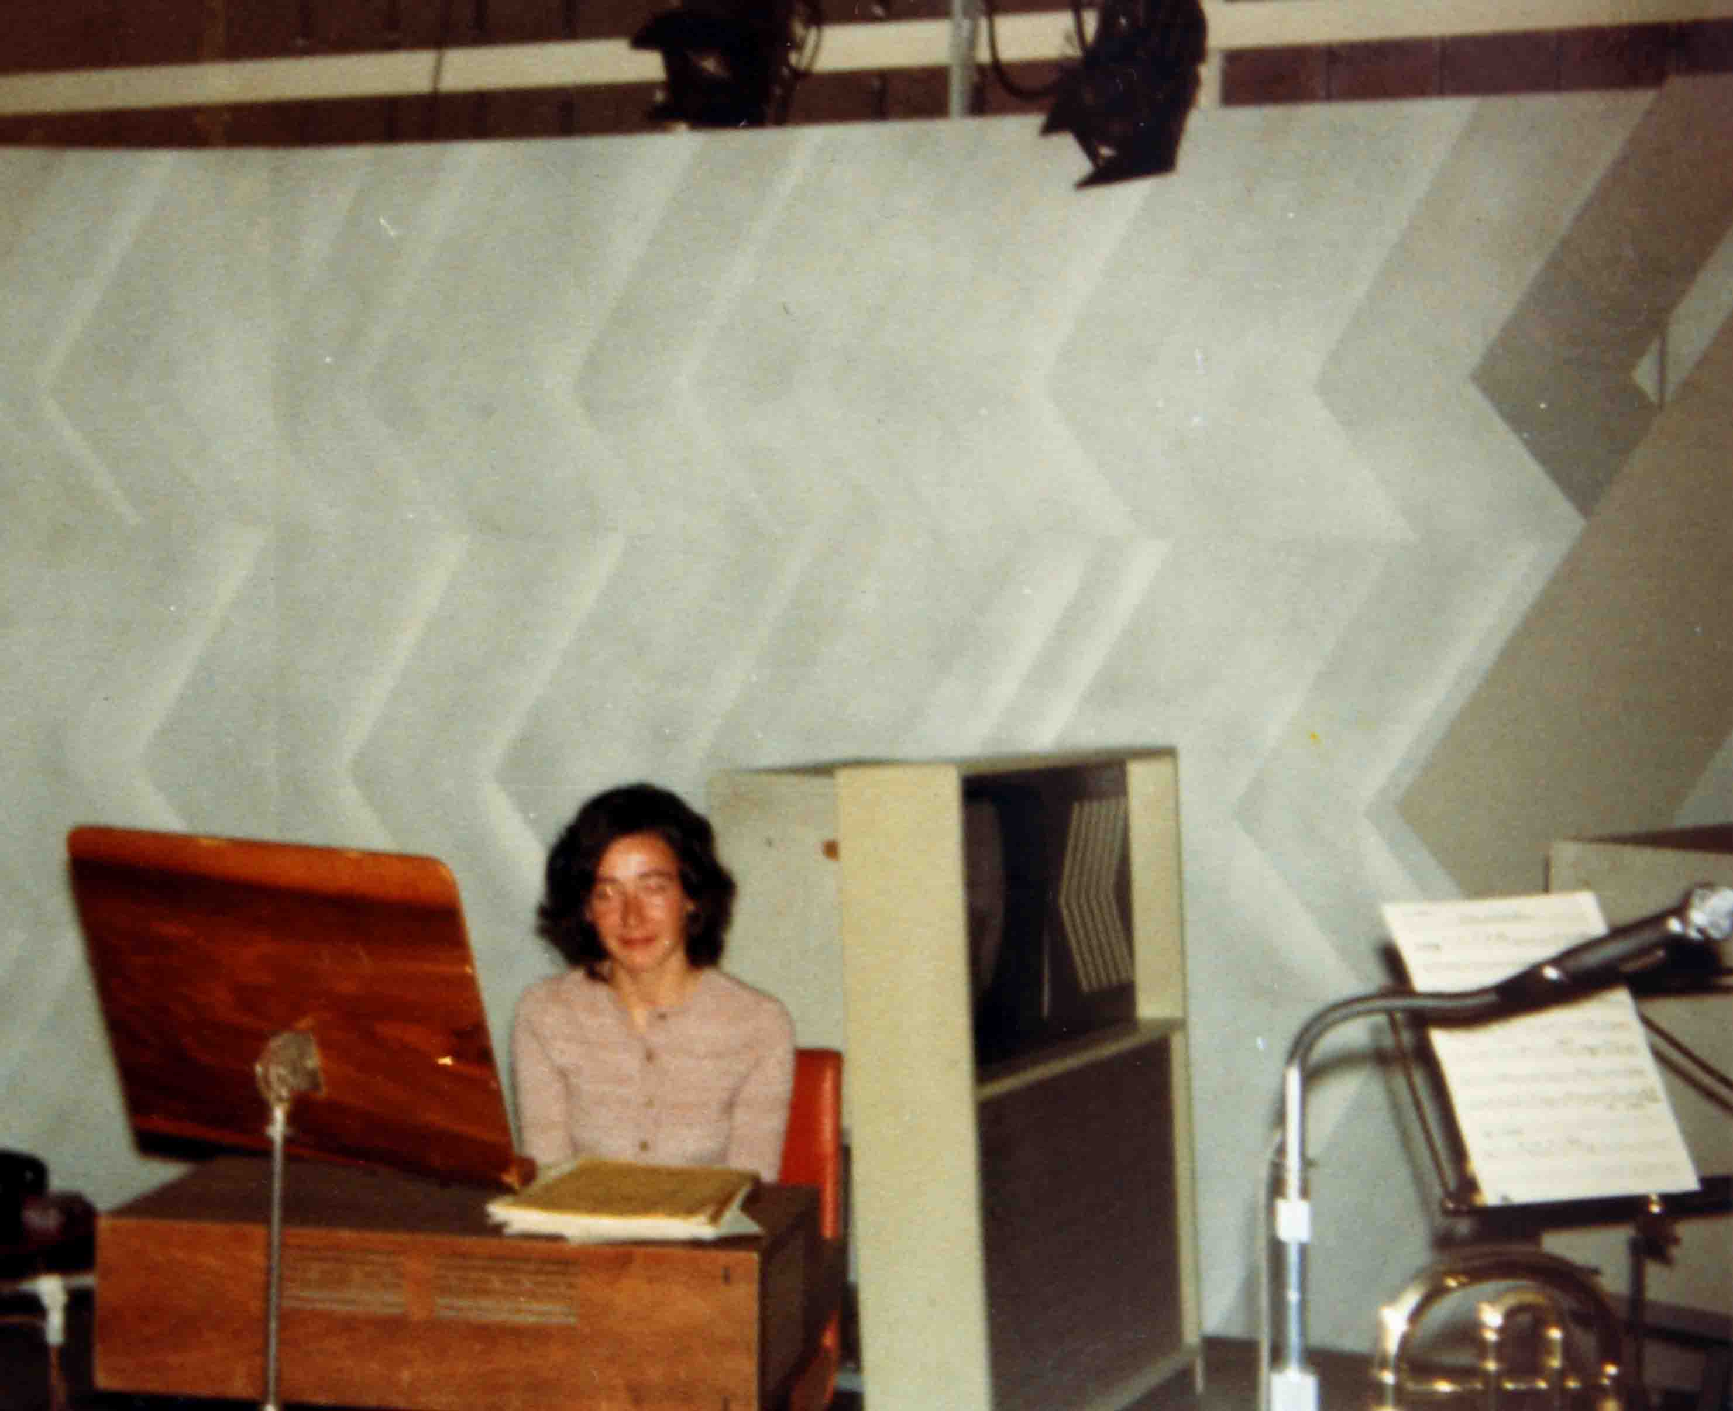

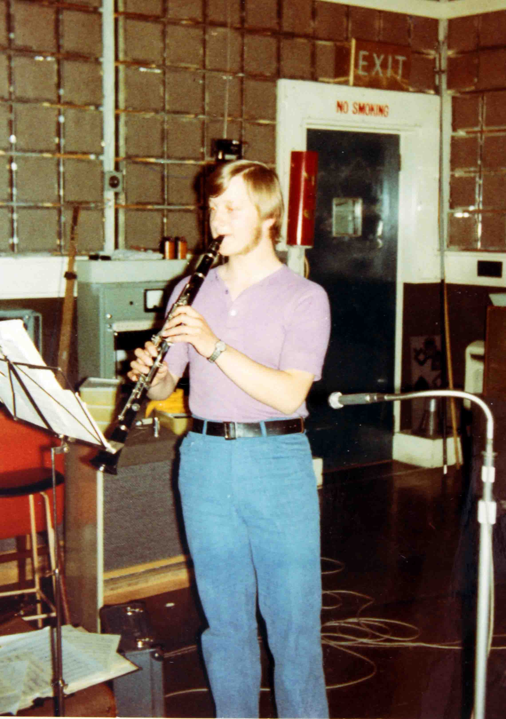

**Simon Cowell would have been proud of you, Dennis!!**

**Back at school, the group often played at the Christmas parties for the lower years and in school assemblies. The group also played in a number of local churches and chapels (hence the name change).**

**As we had now become 6th formers, other privileges were bestowed upon us - we were now prefects who must be obeyed! This usually meant that we stopped the younger ones from running in the school corridors and 'nabbed' younger children to fill up the spaces in the first lunch sitting.**

**As prefects, we were also  allowed to wear a different tie to the rest of the school (or was it a 6th form 'thing'?) Many thanks to Tony Cousins and Geoff Thorne for providing these articles - the prefects/6th form tie can be seen on the left.**

**The black and amber tie was worn in the lower years with some slight variations - the lower tie in the picture has slightly broader stripes and is made from a smoother, shinier material - this may have just been a natural variation from the manufacturers or it may have been an earlier type of tie ( it has the name 'Cath Walsh' inside, can anyone date it from that? - MJ)**

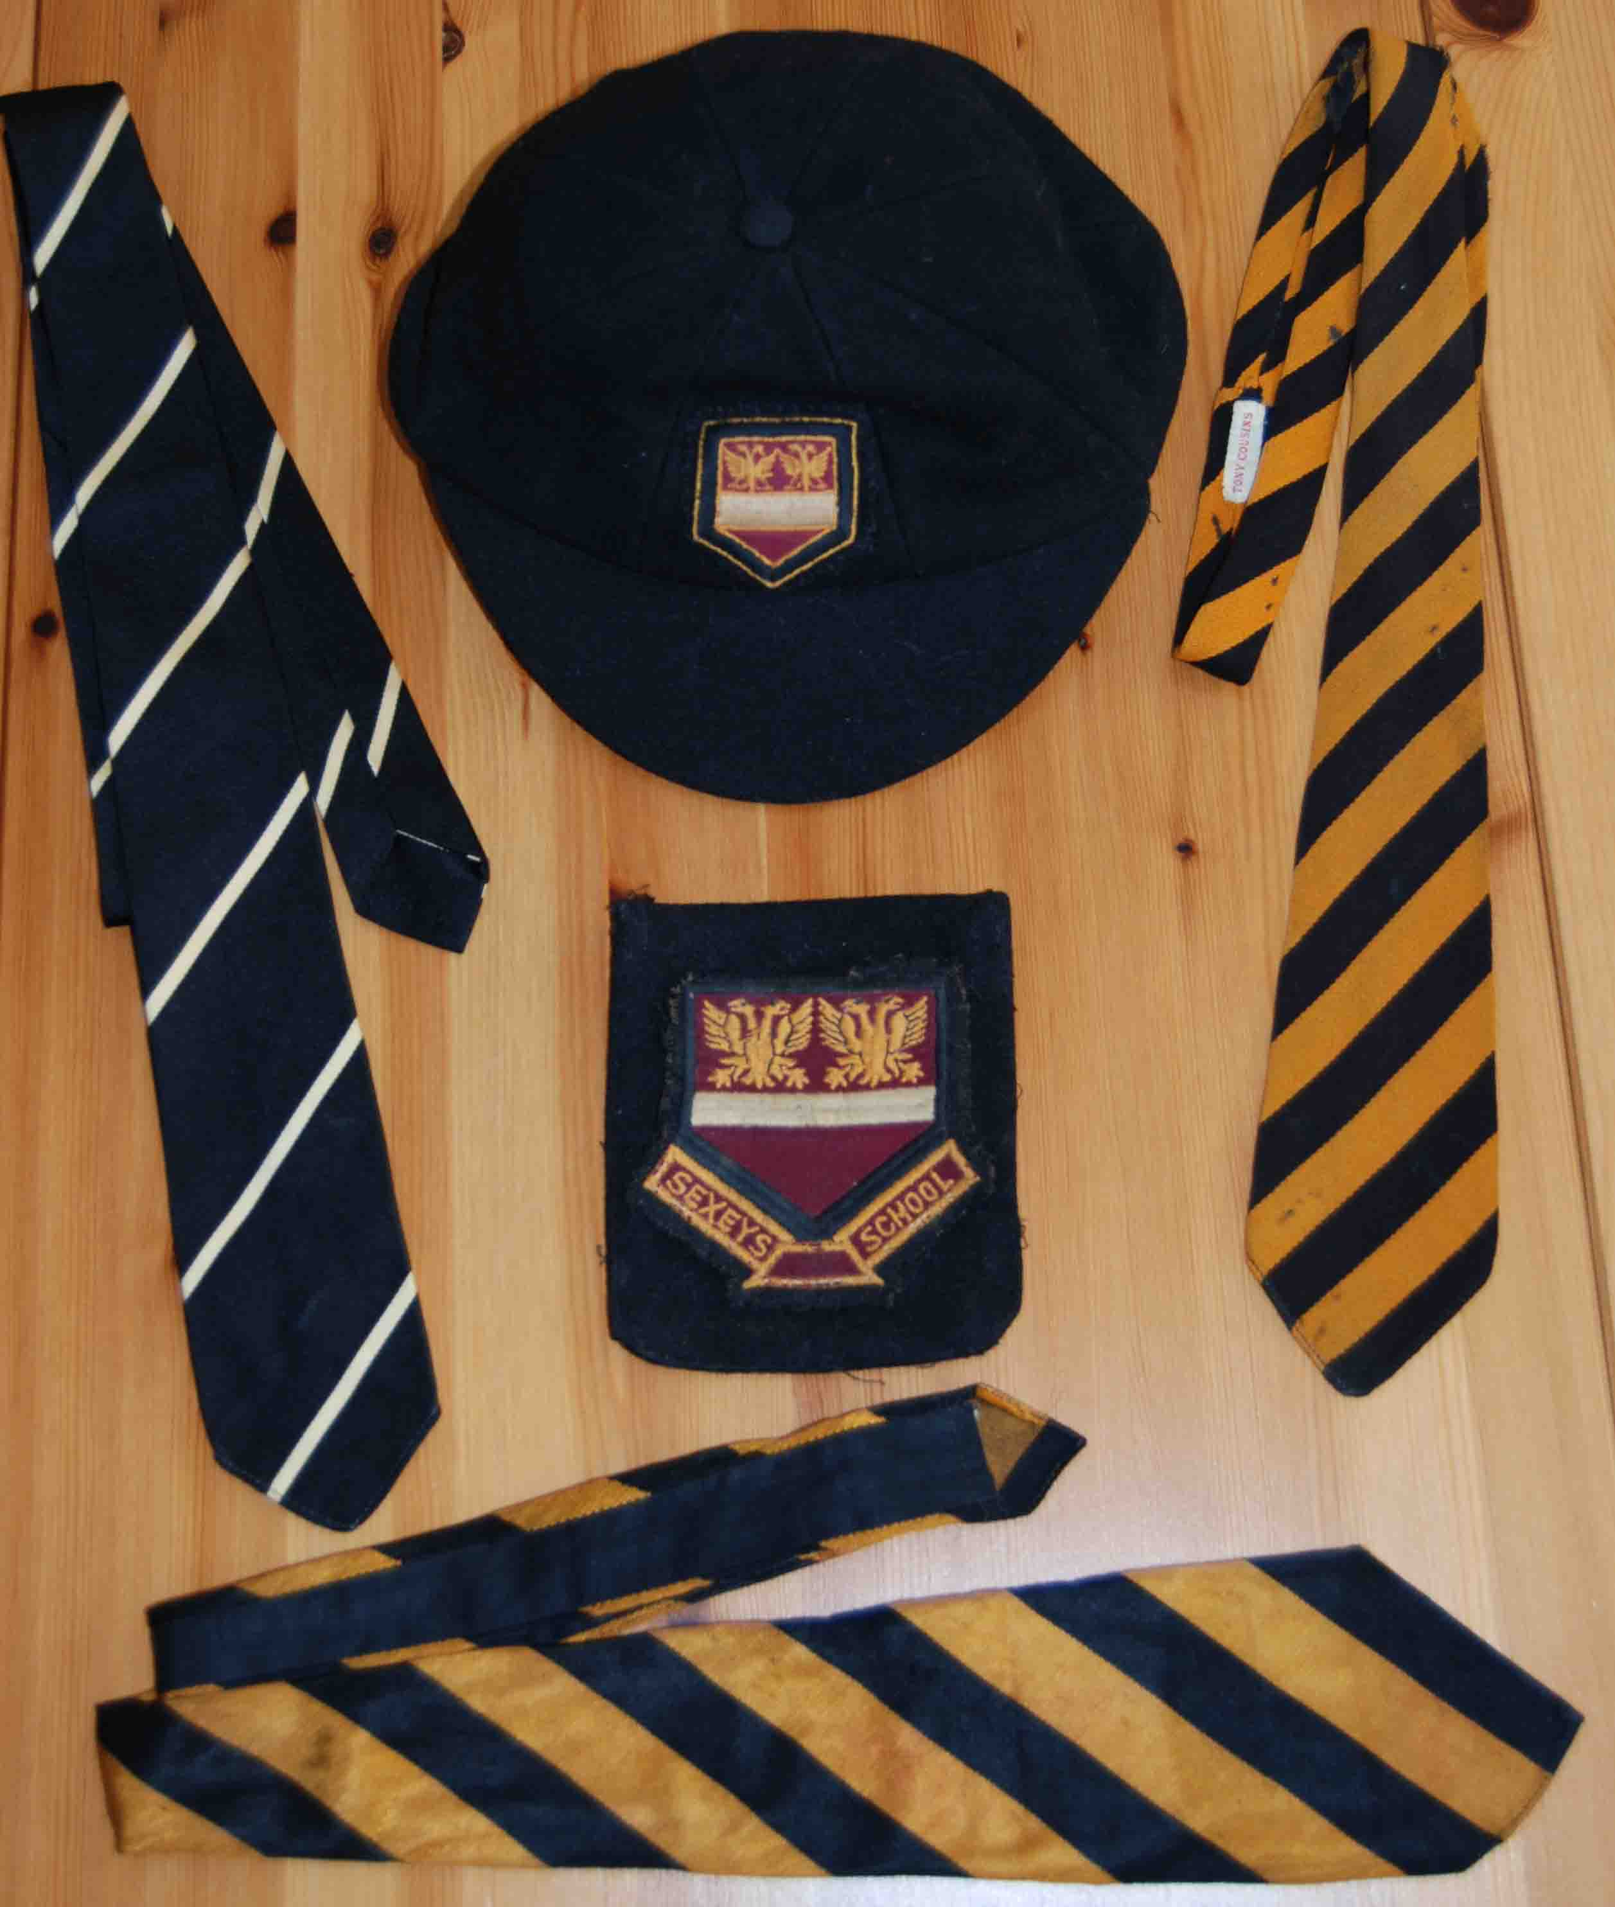

**February,1970 saw my year group heading off to Kilve Court for a week's residential course. To quote the centre's recent (2008) advertising -  'Kilve Court is a Georgian Country House with modern extensions, situated in 40 Acres of wooded grounds and gardens, at the foot of the Quantock Hills and one mile from the sea.'**

**The earliest mention I can find of the school using Kilve Court on a residential basis, was in the 1965 'Old Sexonian', where it mentions a visit made in November '64. The course itself was an 'Introduction to Acting' and lasted a whole week. (Does anyone have any memories of this? - MJ)**

**The 1970 course was for five days beginning on February 16th. The programme (kindly provided by Jane Hill/Tony Cousins) we were all issued with, shows the typical Georgian architecture of the main building.**

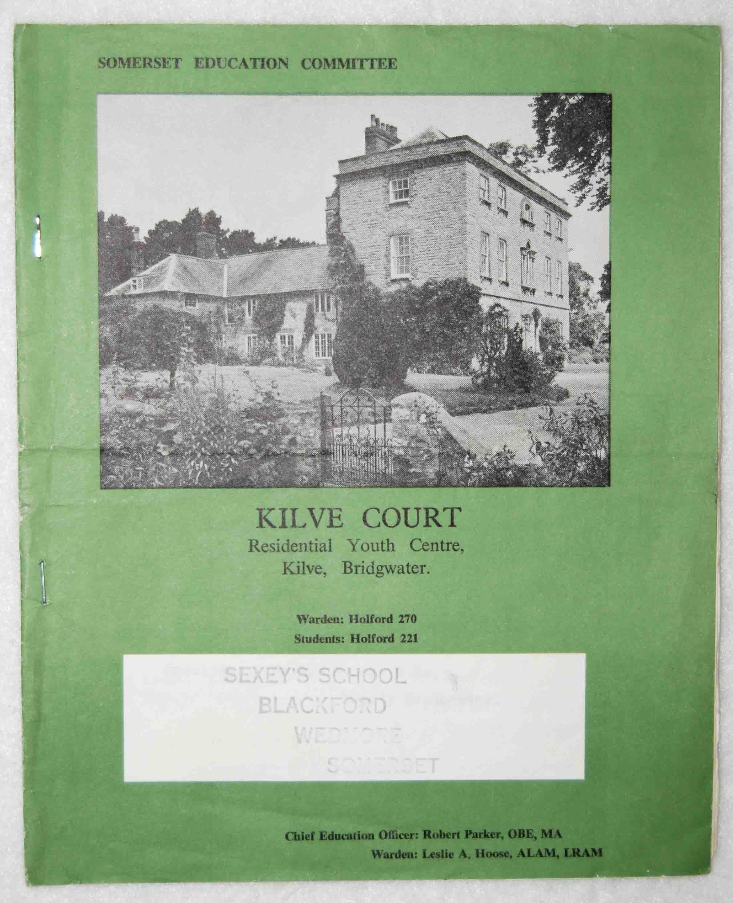

**Looking through the pages reminds me that there was a very mixed programme of visiting speakers and both on and off-site activities.**

**This photo shows the order of activities for Thursday, February 19th.**

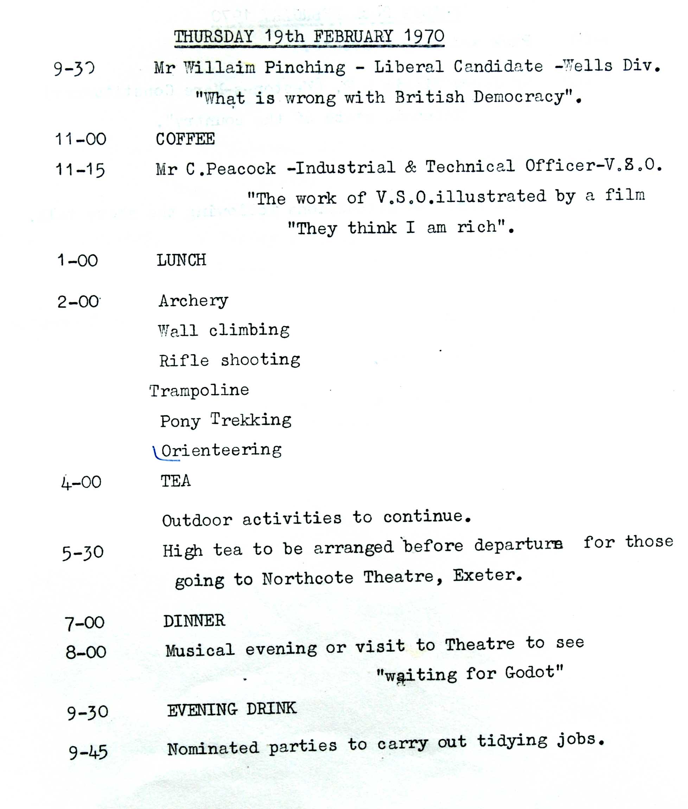

**The one lasting memory I have of the week was when we went pony trekking. We were all kitted up and went off in a 'follow my leader' line up onto the Quantocks. All was fine until the lead horse, ridden by the instructor, decided to pick up the pace a bit. It was only then that I realised that I had no control over the pony *whatsoever*! Whether I pulled left or right on the reins, it just went where *it*wanted to go and at a speed that *it*thought was OK - which was far too fast for *me*!**

**My friend, Geoff Thorne was on the pony behind me and I remember he made the classic mistake of getting knocked off his pony by a low branch (he forgot to duck!) as we went through a wooded area! I don't know about Geoff but I've never saddled up since!**

**As well as attending the actual lectures/activities we were all allotted a job to do, as can be seen from the Task Sheet. From the pupils listed, I can see a few names from the year above ours - perhaps they'd missed the same course the previous year.**

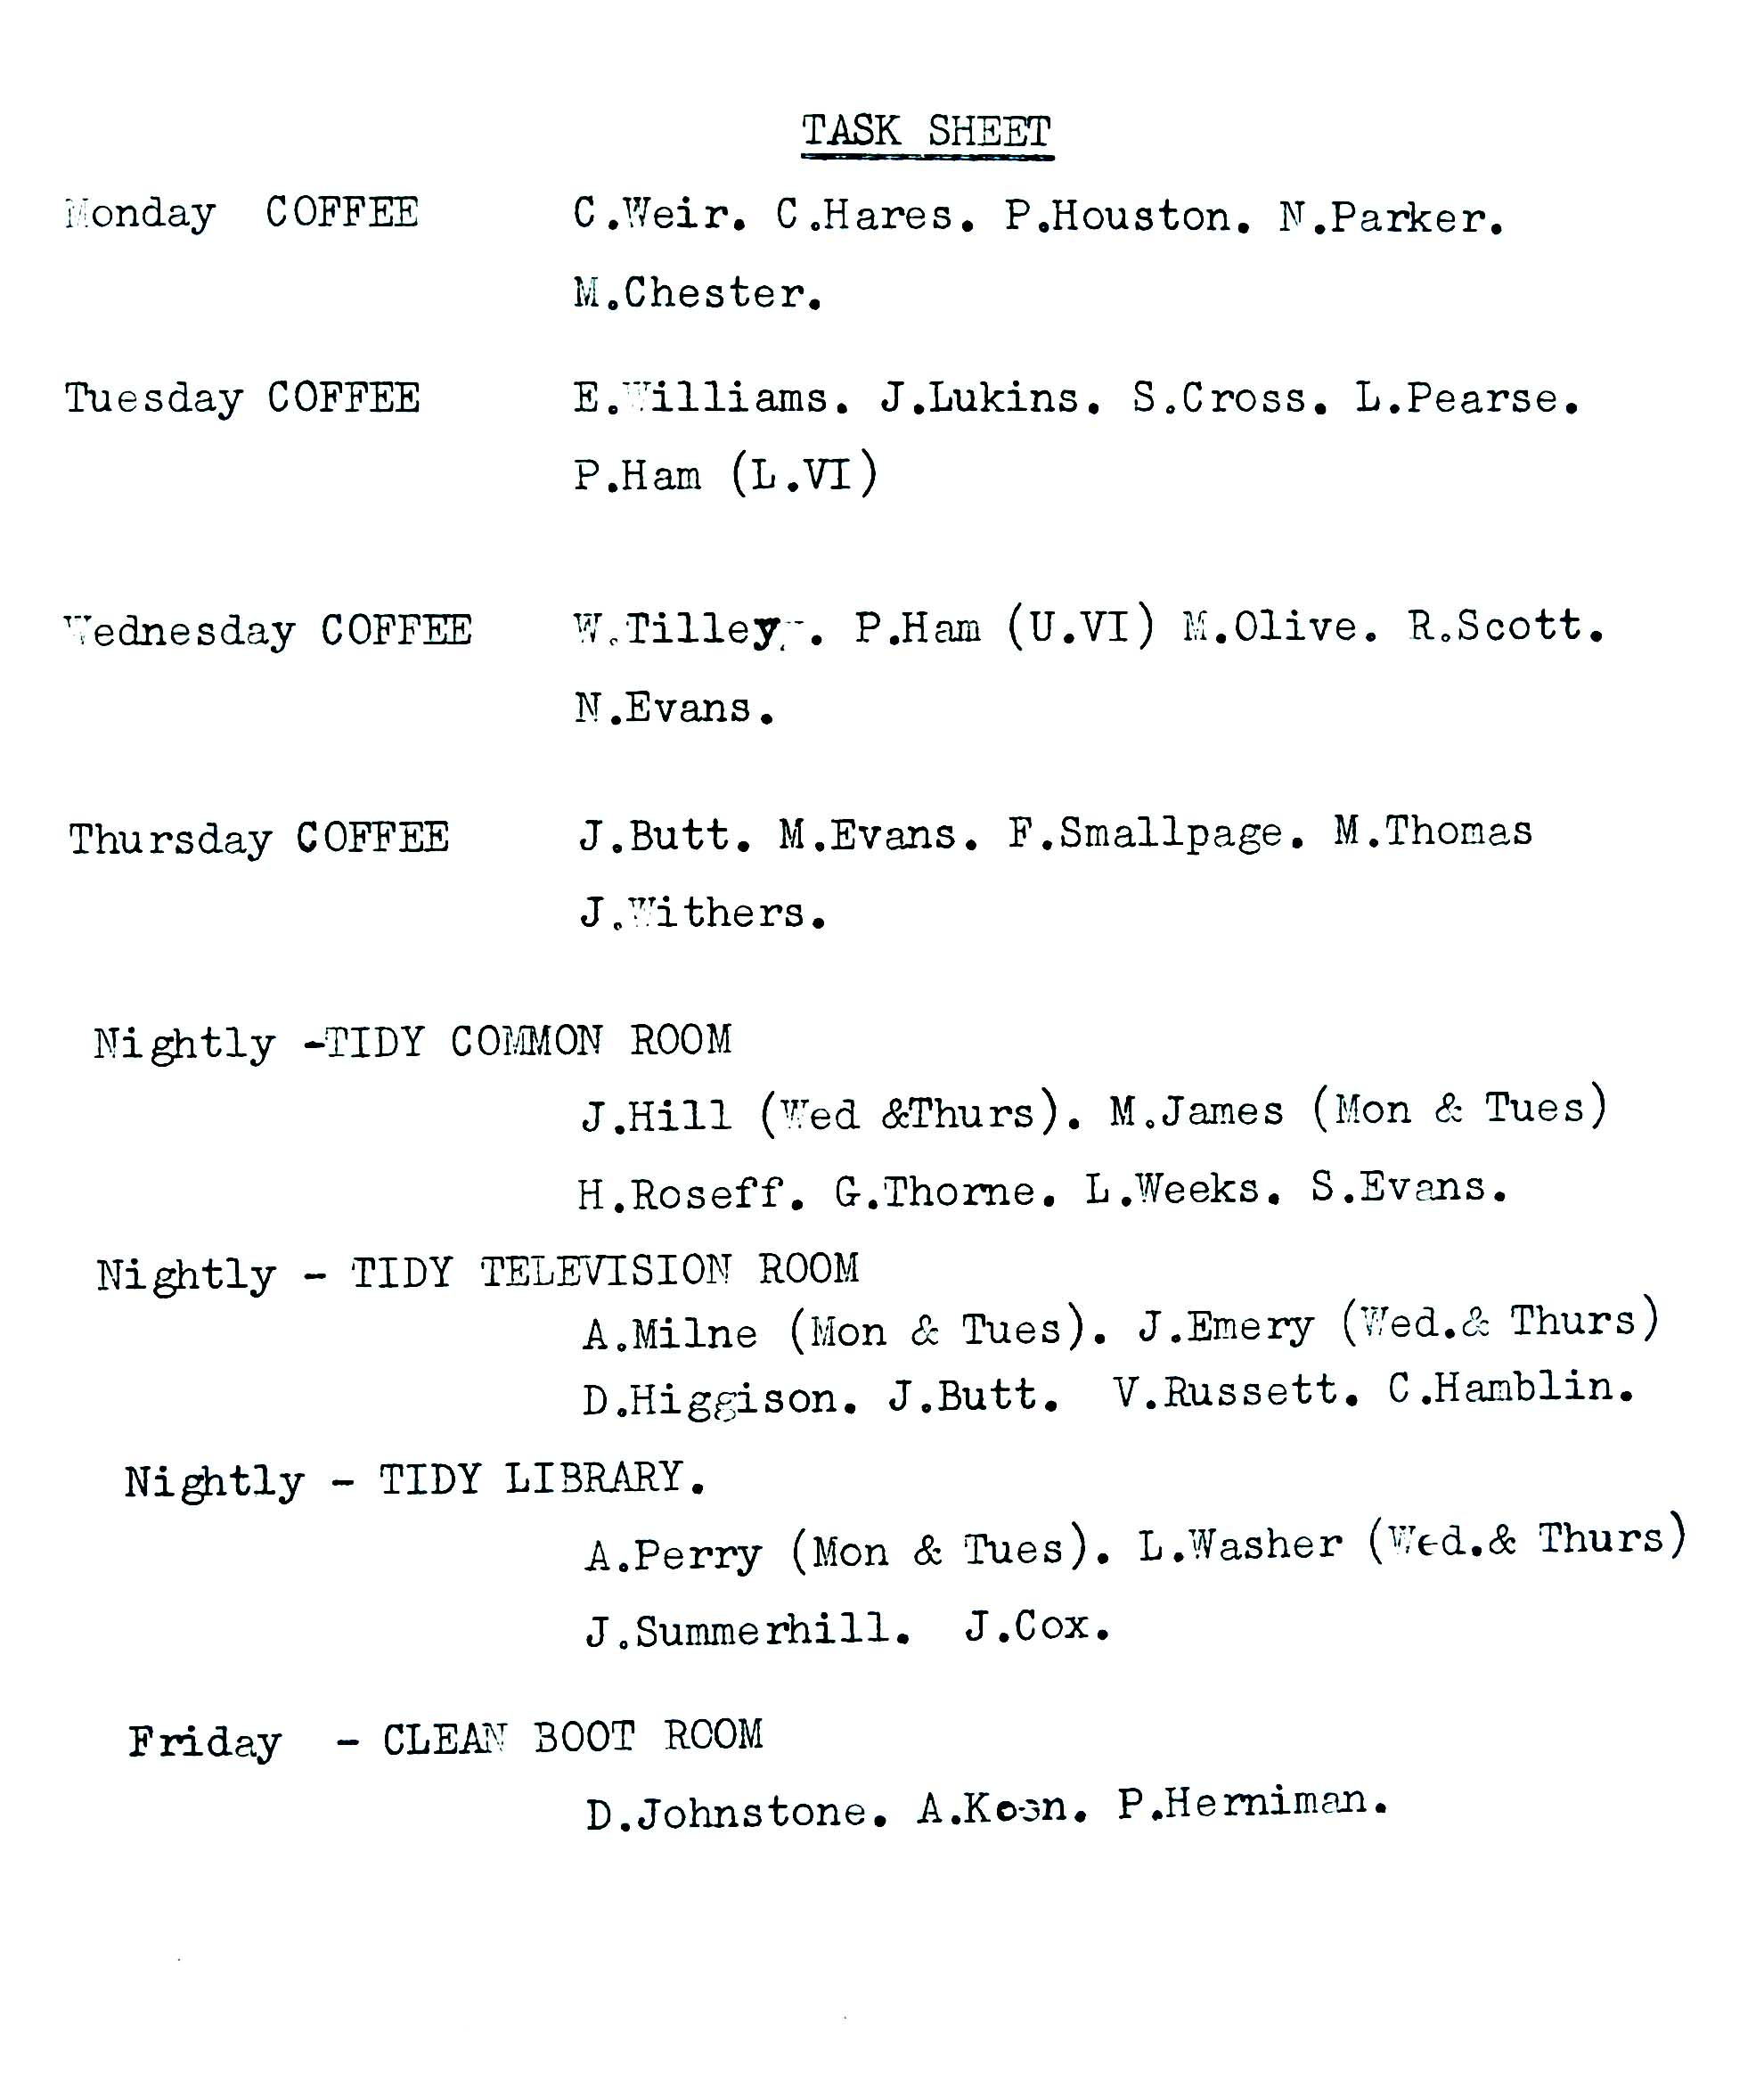

**If my memories are correct the Warden at the time was Dr Lesllie Hoose and Ray Hancock was his deputy. In later years Ray became the Warden when Leslie retired.**

**(I have very fond memories of Kilve Court, both as a pupil and as an adult. As a young teacher I used to help Roy Rendell, who at the time, was the Somerset Schools'  inspector in charge of Environmental Studies, run residential courses there.**

**In later years I took over from Roy and I used to organise and run them myself. Many years later my daughter, Hannah, went on a very enjoyable weekend course there, Ray Hancock being in charge at the time.)**

**About a month after the Kilve Court visit, the school put on a very successful Gilbert and Sullivan production, 'The Yeomen of the Guard'.**

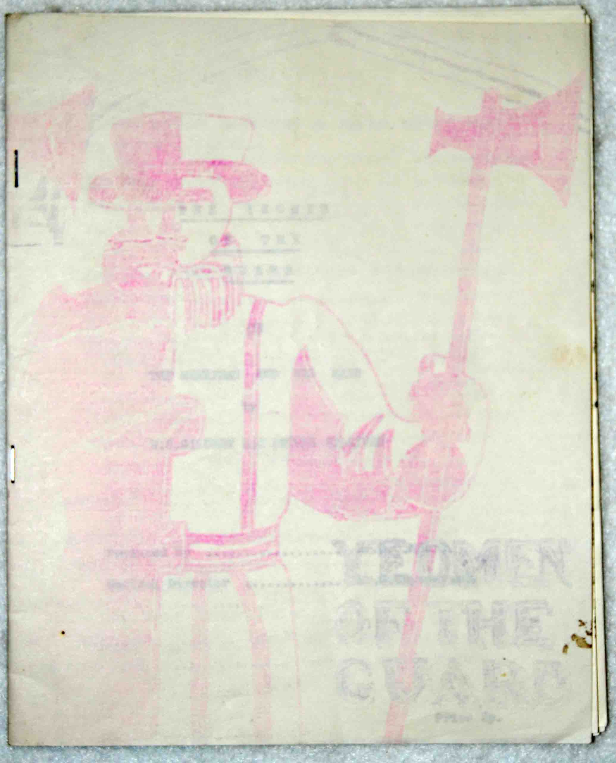

**The production played three separate nights, the 25/27th March.**

**This was the programme (thanks to Tony and Lynda Cousins), consisting of 3 stapled sheets  (the title is only just visible despite a lot of digital editing) which was available for the princely sum of 2p - coffee was available for 5p a cup!**

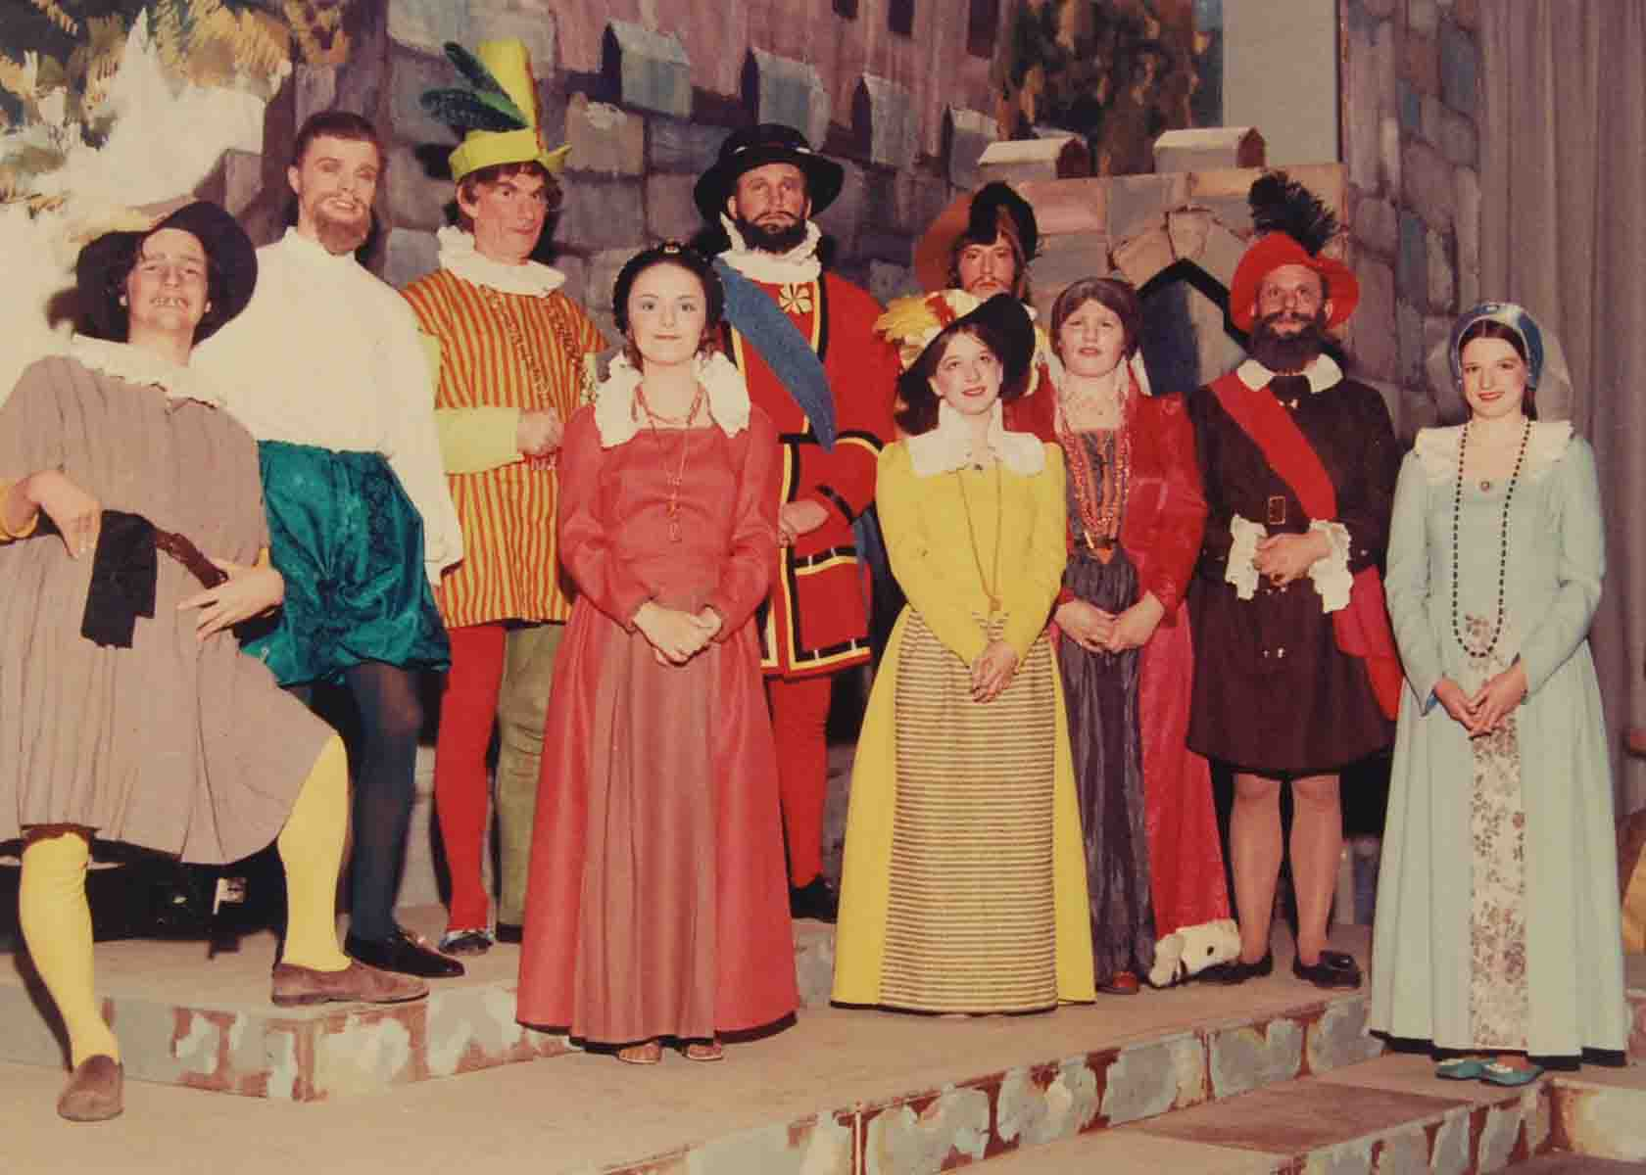

**Looking at the full list of cast members reveals there were no less than 61 of them - I wonder how that compared with previous productions? (A photo of the whole cast can be found in Gallery 5).**

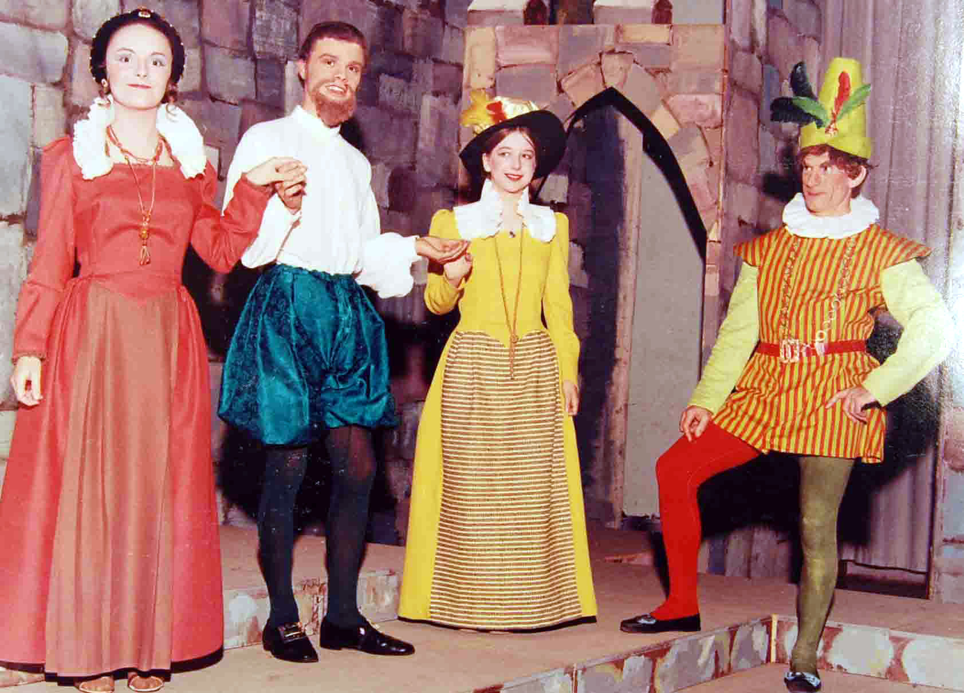

**The musical was produced by Mr Moore and Mr Churchyard directed the music. Members of staff who played leading roles were Peter Lee (Sergeant Meryll) and Mr Ravenscroft (Lieutenant of the Tower).Actually, it was a bit of a family affair for the Ravenscrofts as both his son and daughter (Nick and Janet) played in the orchestra, Nick playing one of two bassoons and Janet playing the cello along with three others.**

**'Behind the scenes' some of the staff members also had a role to play. Fred Roberts was given the title, 'Business Manager', Ray Packer was Stage Manager and Isabel Rendell assisted with the costumes - not forgetting Hubert Fisher (caretaker) who helped with the scenery changes.**

**The production was also covered very positively by the local press.**

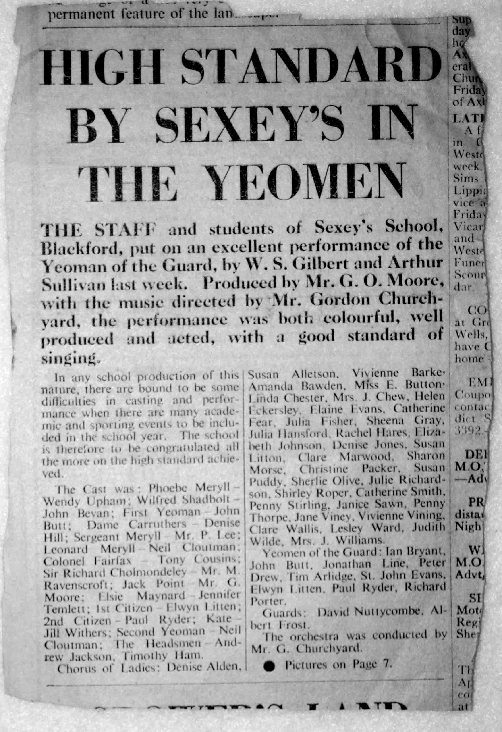

**As it states in the headline, the performance was 'excellent'.**

**(If you have any special memories of this production, please send them in to me - MJ)**

**With regards to our actual schooling in the '70's, I can remember that at some point, a small Biology lab was made by converting the old senior boys boarders' dormitory, (up the stone stairs and turn left) - I got to use that on a regular basis with the rest of the A level Zoology group - ( Mr Brookes being in charge) - I particularly remember dissecting frogs and rats which stank of the preservative, Formalin, (we actually had to buy our own instruments, scalpels etc in those days, some of which I still possess).**

**Fortunately, I did manage to pass my Zoology 'A' level, which is more than I can say for my other two subjects!**

**My other A levels were Additional Maths ( Pete Lee) and Physics ( Steve Chinn)- the least said about those two subjects the better (although I did enjoy many aspects of Physics, some of the concepts and formulae were a bit beyond me and having an abysmal memory didn't help !) - needless to say, I didn't pass either of them !!**

**Many thanks to Jane Hill ( Murphy) for sending me a number of  interesting items from the early '70's, two of which are this 1970 Speech Day programme  and the 1971 edition of 'The Sexonian', in mint condition.**

**This photo shows the front cover of the programme, the whole thing being an A4 sheet of thin card, folded once to A5.This basic design was used throughout the '60's and '70's and probably earlier.**

**A quick look through the Speech Day programmes I've got, shows that the only difference to the front covers is that the later, '70's styling, has a larger school badge, making better use of the space.**

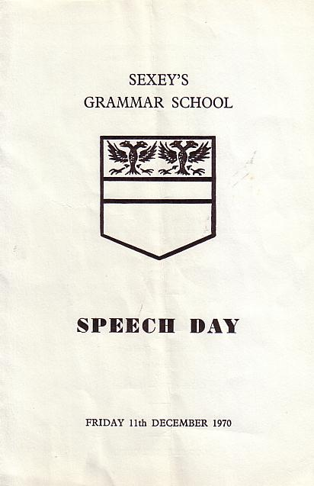

**The format of the interior layout  remained very similar over the years showing, amongst other things, the list of 'A' and 'O' level prize winners that particular year. Interestingly, amongst the 'Special prizes' is a prize given on behalf of the 'Old Sexonians Association' (won by Jane Withers in 1970) - does anyone remember what this prize was actually given *for*?**

**That year, the vote of thanks (for visiting speakers etc) was given by Philip Ham and Christine Weir, the Head Boy and Girl, who were members of my class.**

**Of note amongst the 'A' level candidates that year, was Royston Scott, who did exceptionally well and managed to get four passes.**

**Amongst the 'top notch' 'O' level candidates, Nicola Goetsch, Sylvia Philips and David Besley each had twelve passes.**

**This next photo shows both of the 'prize winner' pages from 1971 programme (many thanks, Jane Hill) . This was my final school year and, hence, all the 'A' level candidates are from my old class.**

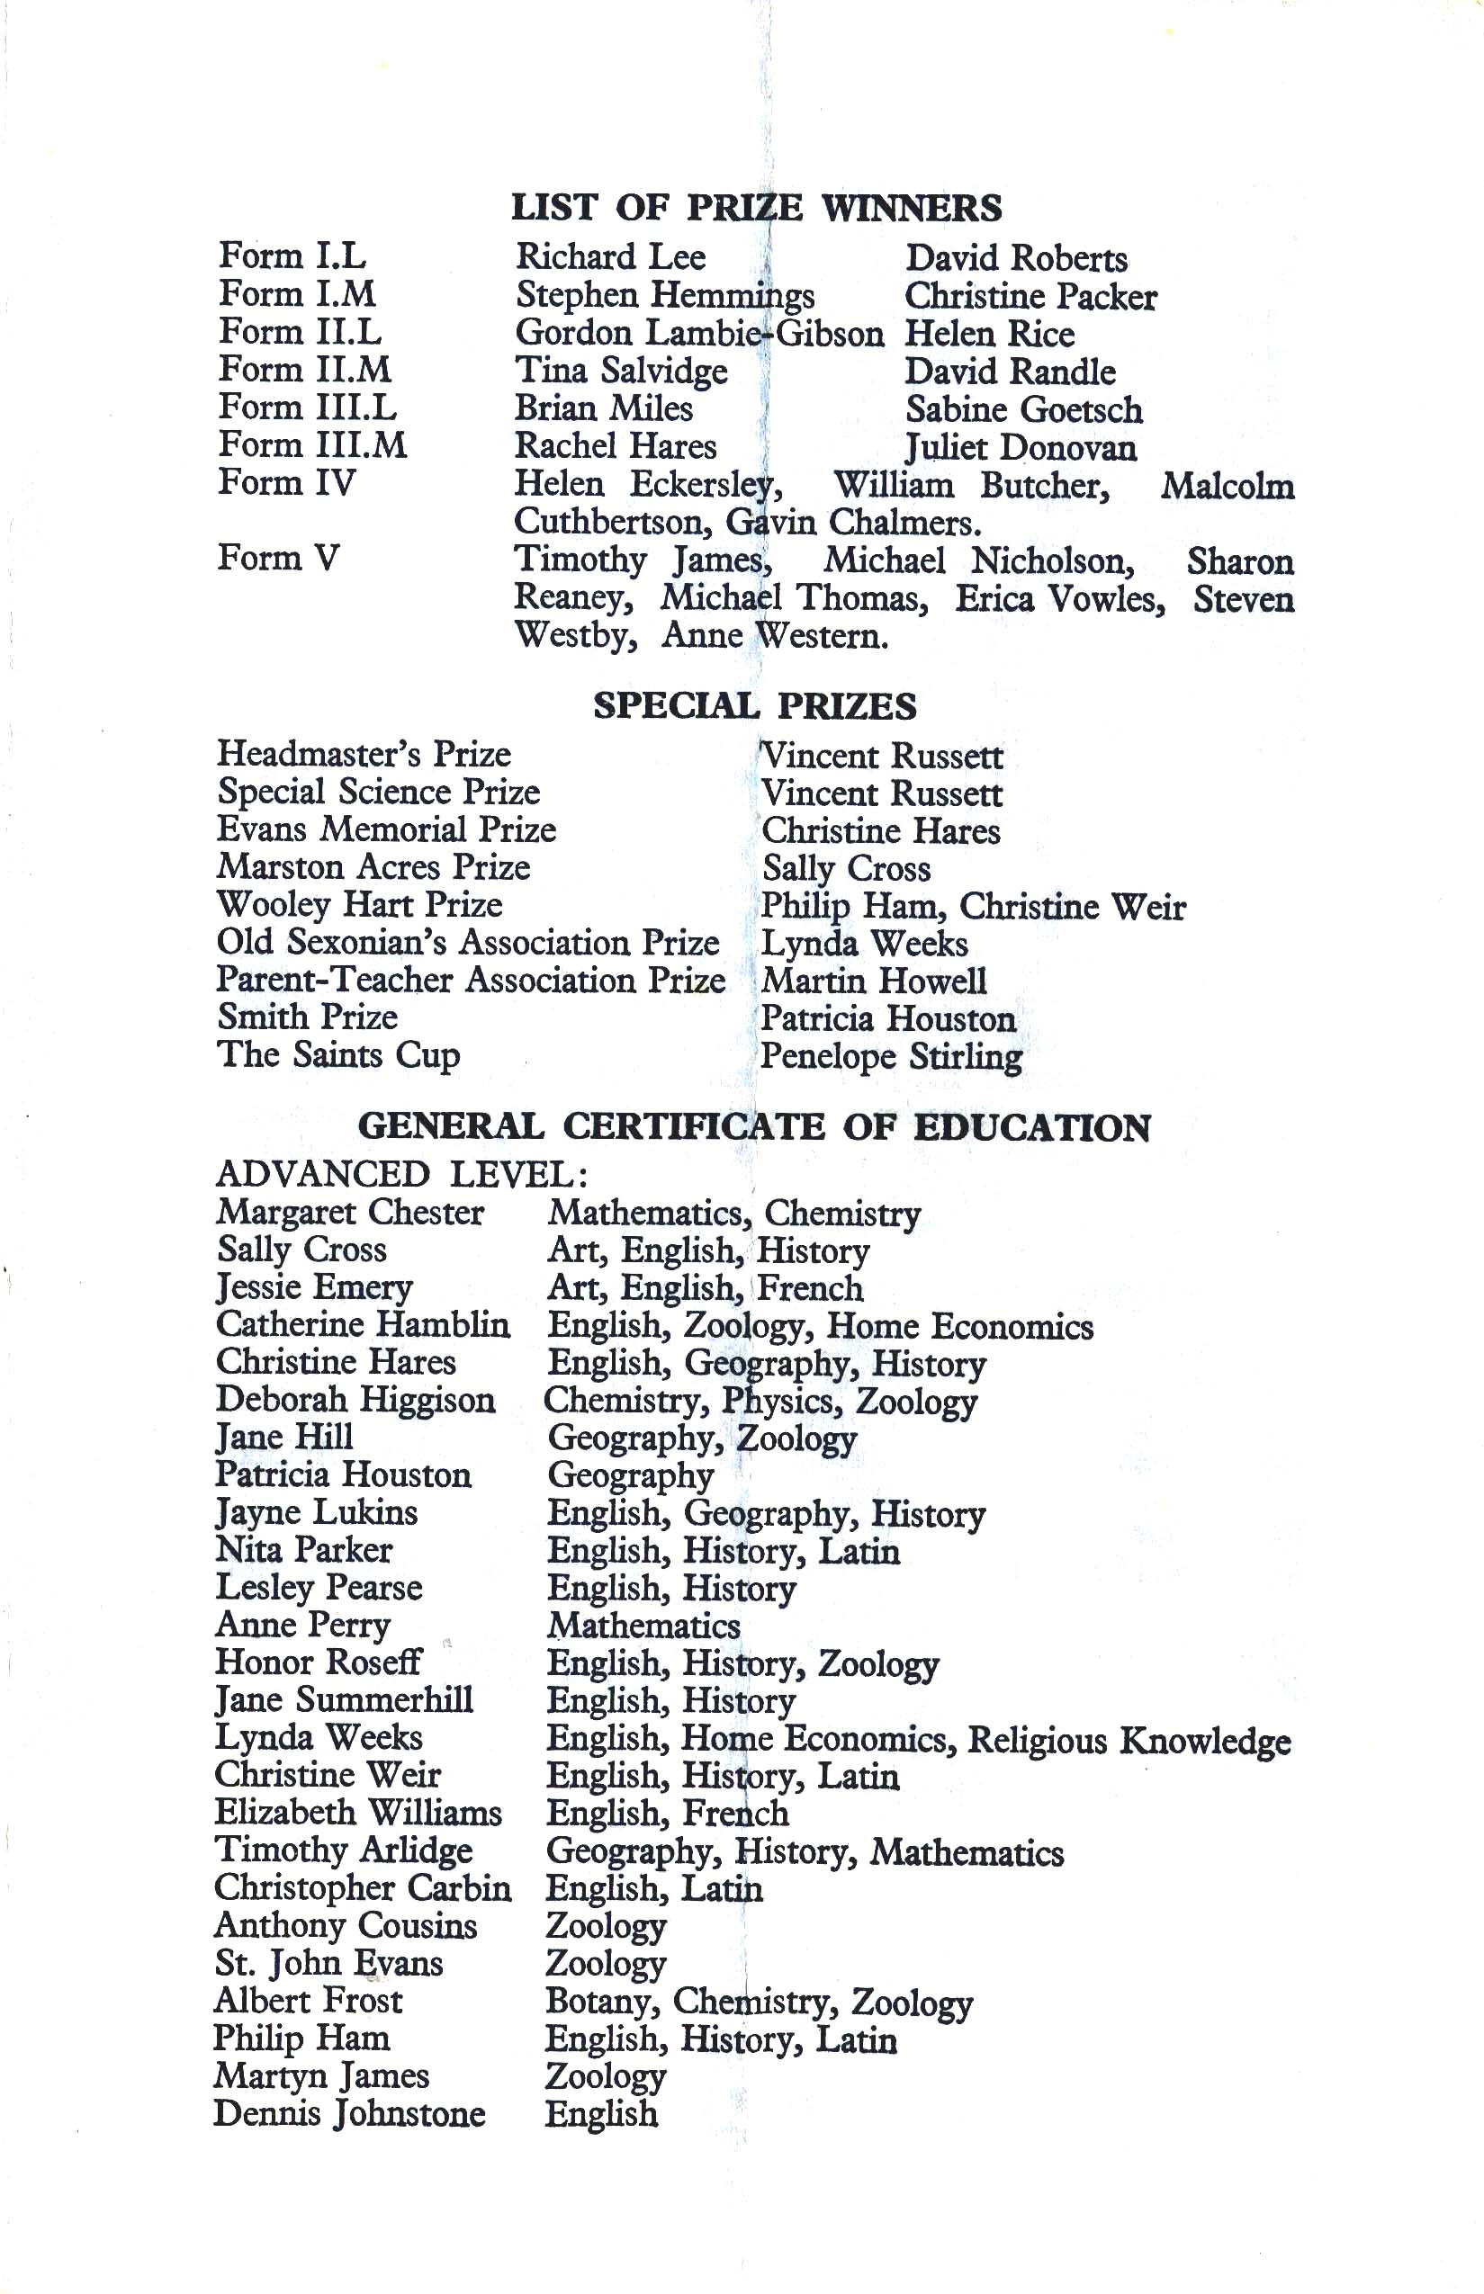

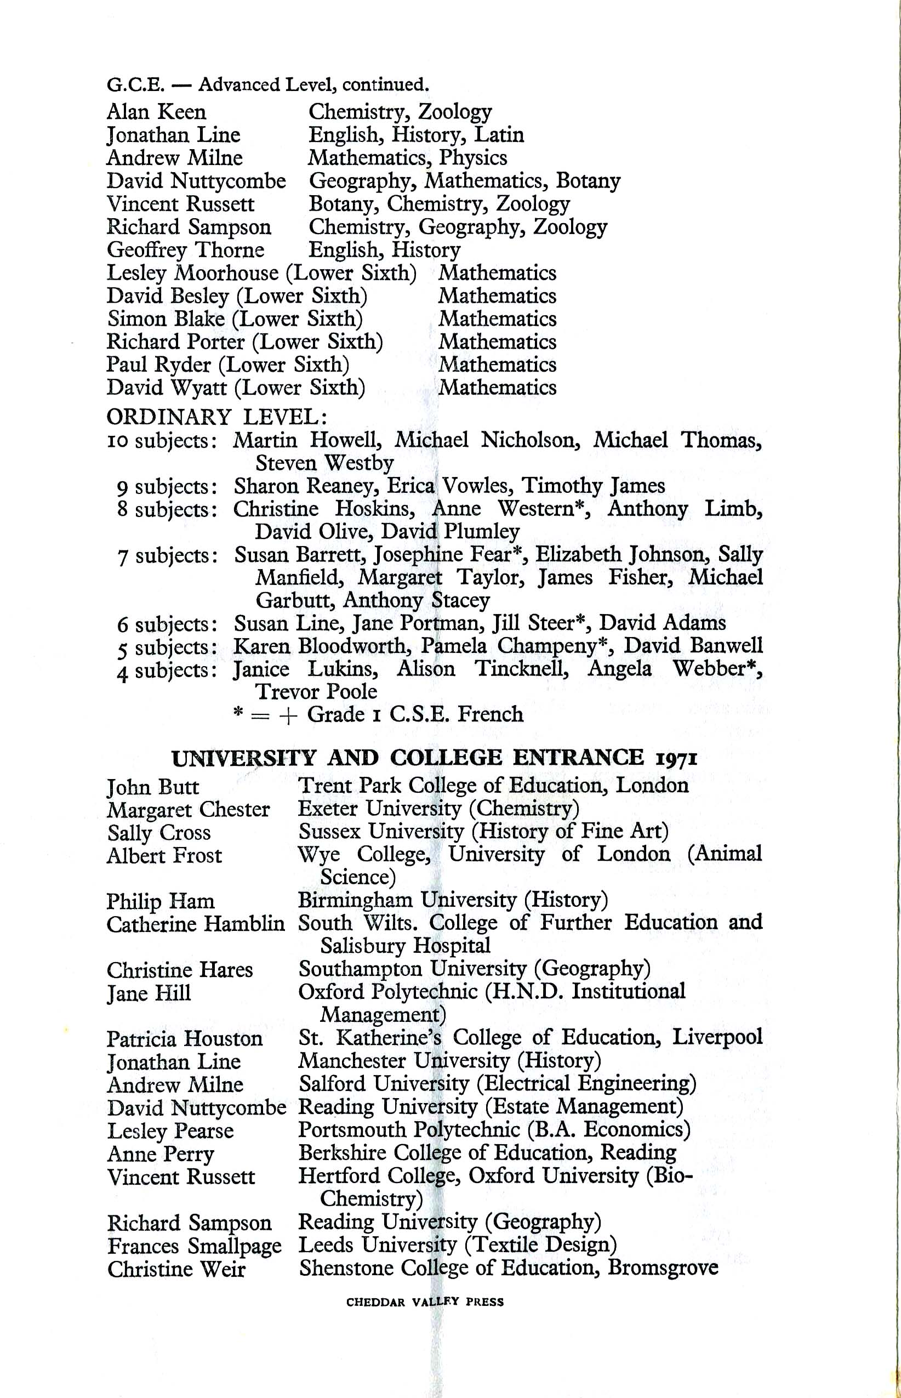

**As well as the academics, we had quite a few 'sporty' pupils in the Upper 6th at the time. In 1970 and 1971? Geoff Thorne was the captain of the senior Cricket team and was a very capable (that's what he tells me!) slow, spin bowler who could spin the ball both ways.**

**Geoff has sent me a school 'colour' which were given to all? pupils who represented the school at senior level. (There's still much uncertainty exactly *why* these were handed out , so if anyone can clarify things , please get in touch. - MJ). According to Peter Gregory  -  'So far as school colours are concerned, when I got mine (soccer and cricket) the practice was to have the name of the sport on a fabric label sewn onto the breast pocket of one's blazer above the school badge.'**

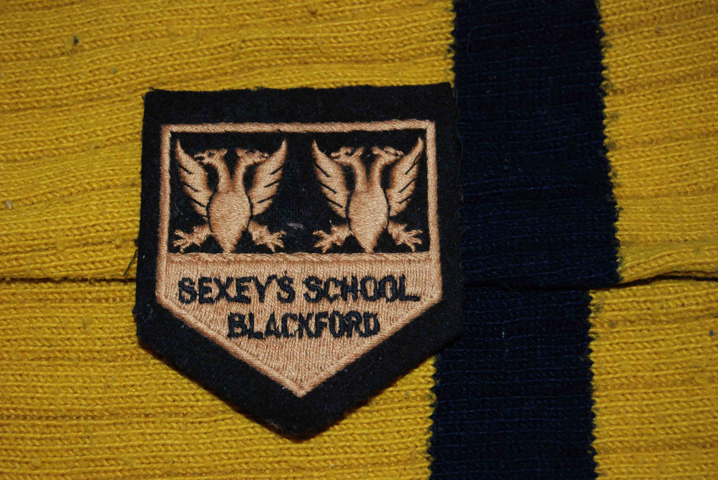

**The 'colour' was a pentagonal, sew-on badge and presumably, when new, was the same amber colour as the school football socks used for the photo's background. As this is the only one that's come to light, it must be considered something of a rarity amongst Sexey's memorabilia.**

**This shot of the 1971 Hockey team was kindly sent in by Jane Summerhill(Franklin) who was a pupil in my year.**

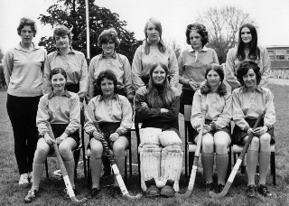

**Back row L-R Miss Beryl Leach, Shirley Olive, Jane Summerhill, Christine Weir, Jane Brown, Debbie Higgison. Front, L-R  Anne Fisher, Lynne Heal, Lesley Moorhouse, ?, Ann Perry.**

**This must have been one of the very last school photos of Beryl *Leach*- in April, 1971 she married and became Beryl Reeves!**

**Jane tells me that her main abiding, hockey memory was having to wait out in the freezing cold on a Saturday morning waiting for the bus to arrive!**

**Lesley Moorhouse (now Sanders) has written in to give us her experiences of the school colours system -  'School colours were given to pupils who represented the school at a senior level - right up until we got to that point (regular 1st team players) and Miss Leach (sports mistress) decided that from then on they would only be given to those who represented the school at *county* level. Since she was the only one who put pupils up for county trials in hockey then she was the one who decided who should have the school colours.'**

**'Anne Fisher and I played for the first team for several years but were not "favoured". It did leave a bitter taste in the mouth. We, the unfavoured were really pleased when after not being put up for trials, Lynne Heal got her local ladies team to put her up. She was selected as a reserve and the "favoured", Shirley Olive, did not get selected (but still got school colours)'**

**'It seemed that in our era, not long after your own, that it was down to the sports mistress which girls got colours and not the amount of representing the school at senior level (swimming, athletics, hockey, badminton.........) - perhaps it was my total lack of skill at tennis and netball, though Anne was good at both of those and still didn't get her colours.'**

**I don't know if the boys were treated in the same way. (Thanks very much, Lesley - MJ)**

**This is the 1971 whole school photograph, taken on the school field behind one end of the swimming pool. It's the final whole school photo for my class which is standing immediately behind the staff row. They are -**

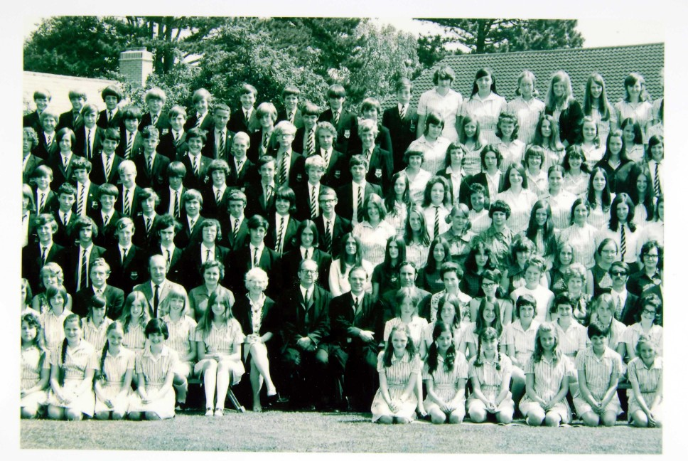

**Behind Mr Ravenscroft (front centre) Andy Milne, left to Albert Frost, me, Paul Herniman, David Nuttycombe, Tim Arlidge and Alan Keen. Besides Andy Milne and going right is Lesley Pearse, Deborah Higgison, Zoe Roseff, Nita Parker, Jayne Somerhill, Lynda Weeks, Margaret Chester and Christine Hares.Needless to say, many of the class are out of shot. (Photo sent by Sally Adams)**

**In 1971 Michael Blackmore joined the school as a pupil, he stayed until the 5th year leaving in 1973 - 'I was in the class with the Eckersleys, Philip Young and David Booth.'**

**Michael remembers Greg Thomas - 'He wanted to play rugby every week. I was useless at rugby and football but good at cross country even after I left school and joined the RAF.'I did woodwork 'O' level with Greg Thomas in 1973 - I failed it'.**

**'I used to take the Wems bus from Mark to Blackford a couple of times - we had to work at home because we were thrown off !'**

**'They gave me a nickname at school because I wore glasses. I played sports but was good at cross country often beating Greg Thomas but could not play rugby. At school I got GCSEs but I was only average. I had friends and travelled on the Wems bus from Mark.**

**'At school in breaks we listened to prog rock on an old cassette player belonging to the late David Milne.** **I did woodwork with Greg Thomas and failed dismally. I had a thing about Miss Button I could not take my eyes off her.' (Many thanks for your memories, Michael - MJ)**

**David Booth finished his schooling at Sexey's in 1975 and eventually went to live in Australia. He still remembers the dreaded 'cross countries' -**

**'It wouldn't happen now in this over-protected world. (I'm sure you're right, David - MJ)  We were sent off on our own on cross-country runs whilst the sports master of the day waited by the old wooden shed that used to be some sort of pavilion.  
In one run we were chased over a field by a herd of young heifers. In another poor Stan Morrissey fell into a rhyne. He had an all white kit on and when he climbed out of the water his kit was completely black.  
One part of the course was along a road which ran parallel to the school field. Dotted along the road were trees. We used to run in the gaps where we could be seen and walk under cover of the trees.'     (I don't know how early on that particular cross country route was used but I know it was in use in the 1950's - MJ)**

**'I remember Irving Kinnersley and I going off to Taunton one Wednesday afternoon while we were supposed to be playing games. All would have been well had it not been for the fact that half of the sixth form had the same idea on that day. Greg Thomas was trying to get together sufficient players for a rugby match and could only just get it together for a bridge tournament!  
I seem to recall that Dave Haldenby wrote a song about the incident - but the words are lost in the mists of time.'    
(Thanks for your contribution, David. - MJ)**

**At the time of writing (Oct 08) the website is definitely lacking in post 1971 offerings, which is something I find hard to fathom. One would have thought that, as this is the age range of the youngest Old Sexonians then we would have more from them than anyone else - we know more about the 1940's than we do the mid '70's !**

**To cap it all, the first article I get from a pupil who was at Sexey's 'to the very end' wishes to remain anonymous!! ( I'm only letting her do this because I know she *was* an Old Sexonian - I don't wish to have a precedent set! - MJ)**

**This female, ex pupil has kindly sent in an ode based upon her memories of the WEMS buses and her journeys to school. WEMS were based in Weston Super Mare and had a livery of grey with green detailing. They were taken over by Bakers Coaches in 1981 and from then on the name disappeared. Here are her memories and the ode to WEMS coaches -**

**'I am totally thrown back into the past by your site (which I stumbled on looking for something else.)I started at Sexey's in 1971 so we only just overlapped.'  
  
'I remember being totally in awe of the prefects - sophisticated men and women - when I was a terrified 11 year old from Cheddar Primary. With regards to the uniform worn by the prefects, I don't think it was just the tie which was different, I'm sure you wore suit jackets as opposed to Blazers and some of you had waist-coats. Was there some-one called St. John?- I associate the waistcoat with him.'   (Yes, St. John Evans in my class often wore a waist coat - MJ)**  
**'Was Tony the one who won the long cross-country and then 'threw up'? If so, he had a large, devoted following of little girls at that time.  
My dad managed to get me a kipper tie in the exact school colours which I wore in a Winchester knot with great pride. I loved the boater but hated the winter hat.'**

**'How crap was the swimming pool? How fab was Hubert? How evil was the DS teacher? Was Penny Stirling in your year? (One year below - MJ) We all looked up to her as well. Did Geoff have dark curly hair and a bit of a skin problem and was really nice to us 'low-lifes'?'**

**Last I heard, Doc Chinn was running some kind of special school. Whatever happened to Mr Moore? What an inspirational teacher! I remember how Mr Churchyard used to make us walk twice round the field if he thought we had breathed noxious gases! (I'm sure that fume cupboard got condemned at some stage! - MJ)  
  
Anyway, here is an offering, which the girls who travelled on WEMS coaches may appreciate.**

**WEMS   
   
Itchy, scratchy seats on bare summer legs,  
sitting on your own was sad.  
Running to the quad to find your coach,  
hoping you didn't have 'Chad'*.            
   
The boys in the back seats,  
loud and short  
but strangely attractive,  
if you like that sort.  
   
Taking off your bag and tie,  
chatting away each mile.  
The embarrassment of your Thermos  
rolling down the aisle.  
   
Shiny, lethal ashtrays  
on the seat ahead,  
many people played with them,  
many people bled.  
   
The smell of last night's revels.  
Windows in the ceiling,  
Bumping your head on every bend,  
a generally queasy feeling.**

**Too many bags on Tuesday,  
Science, D.S., P.E.  
Muddy puddles in the gang way,  
Basket on my knee.  
   
Boaters tossed around the bus,  
Beeping emergency door,  
Fifth-form back-seat wannabees,  
Fighting on the floor.  
   
Looking forward to the sweetshop,  
Gosh! A shilling went so far,  
Black-jacks, shrimps, fruit salads, laces,  
Curley-Wurley, sherbet pips or Big Six Bar!  
  
   
They got us there and got us back,  
nearly every day.  
Almost no-one got really hurt.  
All Hail the green and grey!**

**I was on the coach that went to Cheddar - "Badgeworth" is springing out at me but that could have been another one.   
   
'DRIVERS - Chad* was a very grumpy old driver, so named because his pendulous nose would have hung well over a brick wall and his motto would have read "What no sense of humour?" With hindsight, I can see why he may not have looked forward to the school run.'  
   
'There was a 'spivvy' driver who reminded me of Walker from 'Dad's Army'. He had dark hair, a pencil moustache and rock and roll clothing. He also had a liaison with a girl who worked at the Solicitor's office in Wedmore and used to make us wait ages, whilst he went in for a kiss and cuddle, sometimes in full view of us all! I think his name was Vincent or Victor.'  
   
'I remember that we rated the drivers by the radio station they played and the volume if it was 'Radio One'. (247?) Every girl on the bus knew the words to each song in the top 20. I remember hours spent taping and rewinding on a Sunday night (just before 'Sing Something Simple'), on a tape recorder whose buttons looked like piano keys and writing the words out in my rough book.  Further hours memorising the content of 'Jackie' magazine and 'Fab 208'! (God, I hope it wasn't just me!)'**

**'There was a kind chap, called Lawrence who had dark curly hair and lived in Hutton. His dream was to open his own coach company, I hope he did. He always put 'Radio 1' on - nice and loud!!'**

**(Thanks very much for the amusing poem and your other memories - I think with everything you've mentioned, there'll probably be a few ex pupils who can make a reasonable guess at your true identity!! -MJ)**

**All I (MJ) can remember about the school coaches is that my bus stop was on Berrow Rd outside the Community Centre in Burnham on Sea and that more often than not fellow classmate, Debbie Higgison, would be parked where the coach pulled up, in her boyfriend, Steve's, much modified, bright orange Mini Cooper S - isn't it strange how some tiny things stay in the memory?**

**Naturally, the oldest pupils tended to sit at the back on our bus, although I don't think we got up to anything particularly exciting. We had a fairly regular driver called Ted who was a 'good bloke' and I believe he remained a coach driver around the local area for quite some time after the 1970's.**

**Wendy Upham (now Callear) has sent in her memories of one of the drivers I'd forgotten all about - the name 'Moody' was certainly very apt!**

**'The coach driver I remember was called Mr. Moody. We were all terrified  
of him! Moody by name and nature!'  
  
'I remember getting to the 8.10 a.m. pick up, just around the corner from  
my house in Ashley Avenue, Burnham, a little late and missing the  
coach! I didn't dare go back home and face the wrath of my mother so I  
caught a service bus as far as Mark then walked the extra 3 or so  
miles. I was terrified, walking along the country lanes on my own. To  
make it worse, a bull appeared in the road, walking towards me!  
Luckily, the farmer was close by and managed to call it back with  
strange, unearthly sounds. I arrived at school during the first lesson,  
taken by Miss Padfield. I was tired, stressed and in trouble!'**

**Ron Eckersley has sent me in this piece about his memories of Greg Thomas. (Greg introduced rugby to the school, something that didn't go down to well initially but which eventually flourished. In one of the first games I ever took part in (in our weekly games session) I can remember Greg, ball tucked under one arm, charging down the field yelling at me to tackle him - there was no way I was going to tackle him ! The only lad I can remember tackling him successfully was fellow class member Dave Paul who was much better built than the rest of us and he could actually catch Greg Thomas too! - MJ)**

**Greg Thomas Takes us to See the All Blacks Play at Newport 1973**

**Greg Thomas took over as games master in 1968, arriving that autumn and quickly introducing rugby as a sport and a culture. A Welshman himself , Greg soon got a place with Bridgwater and Albion Rugby Club and took a group of lads including my brother David to watch him one Saturday. Unfortunately, he got carried off with a broken leg during the match and as he was the driver, there were a few phone calls to anxious parents later that evening to arrange journeys home. ( Ron, I can remember that match and I can still see Greg being carried off by stretcher. If I remember correctly, Mr Ravenscroft, the school's headmaster, took some of us home - MJ)     Despite this setback and Greg's temporary lay-off, interest in rugby grew unabated and it was inevitable we were going to want to see the New Zealand All Blacks play at some point during their historic 1972/73 tour of the UK. Greg got us all excited and a coach trip to Newport was arranged for the early in the new year.**

**The trip to Wales was uneventful though once at the ground we found ourselves, 30 English schoolboys in Sexeys school uniform, amidst a sea of 26,000 Welshmen including miners who'd bunked off shifts. Their beloved home team were putting up a valiant fight against the visitors but with talent like Grant Batty and Sid Going, the All Blacks were to grind them down. Despairingly, David called out at some point during the game "*Come on you Welsh B******s!*" at which, a sprightly octogenarian tapped him on the shoulder and said "*Don't call them bastards till after the match ...if they lose this we all will!*" The huge crowd was pretty dispirited when Newport eventually went down 20:15 but we'd seen a wonderful exhibition of rugby.**

**Our return trip was boring as it was dark, the bus was slow and we'd all finished our sandwiches which, in those days, parents wrapped up in aluminium foil. The foil could be screwed up into hard balls and we had harmless fun tossing them around the back of the coach until someone incited Philip Duckett to chuck them out as cars as they overtook us going over the Severn Suspension Bridge. Once out of ammunition though we settled back down for the remainder of the drive home. However, our slumbers were disturbed by the Avon and Somerset Police highway patrol which flagged the bus down on the hard shoulder and a copper got on the bus. He spoke to Greg and there was pointing to the back where we were all quietly trying to slip down behind the seat backs.**

**The copper got off and drove away - you could have heard a very small pin drop in the silence as Greg stood up and moved back - he was very controlled and spoke slowly but there was no disguising the wrath behind the words. "*Right you lot, straight after assembly tomorrow I want to see you in the woodwork Lab*."**

**The lecture that next morning was to involve a lot of chest poking with a baulk of timber, one of Greg's favourite scary moves, but no one squealed so we all got the same sanction that has now, mysteriously, been expunged from my memory. Fortunately, for us Greg did not involve Podge or the Nose (Deputy Head and Head) and the police didn't take it further either  
(Many thanks for this article, Ron. Over the past 12 years or so I've been totally coverted to rugby and I've supported Bath for many years - MJ)**

**THE 11-PLUS EXAMINATION**

**Could you pass the 11-plus? Exam papers first used in the 1950s puts you and your family to the test (supplied by John Grant)**

Most Old Sexonians passed the Eleven-Plus Examination, which was largely phased out in the mid-Seventies. How would you fare now? Whether you just browse the Questions or sharpen your pencil and attempt to pass the examination again, you may find a surprise or two. Would your children and grandchildren pass a similar examination to the one you passed? (For copywright reasons I have had to precis the text by omitting the 'General Knowledge' and 'Essays' section of the exam - hopefully the overall standard of the exam (very high for 11 year olds!!) can be seen in the remaining questions - MJ -The answers are shown at the end.)

**GENERAL ENGLISH**

1. Make adjectives from these nouns: beauty, slope, glass, friend, doubt, expense, delight, sleep, danger, sport.

2. Write these lines of poetry in the usual way, putting in capital letters and the correct punctuation: the evening is coming the sun sinks to rest the rooks are all flying straight home to the nest caw says the rook, as he flies overhead it's time little people were going to bed.

3. Choose the correct word from those in brackets:

a) She gave the (fare, fair) to the conductor.

b) I am (confidant, confident) of success.

c) Why does she (die, dye) her hair?

d) His sister has (wrote, written) him a letter.

e) The screw fell off because it was (lose, loose).

4. Fill in the relative pronoun in the following sentences:

a) That is the coat .......... my brother took away.

b) The man to .......... I spoke was very disagreeable.

c) The boy .......... ball I kicked was offended.

d) The man .......... does his duty is always brave.

e) He asked me .......... I intended to do.

5. Each of the following sentences contains one error. Re-write the sentences correctly:

a) This is not an Infant's School.

b) I am told that Tom Jones's brother have won a scholarship.

c) The bishop and another fellow then entered the hall.

d) When the dog recognised me it wagged it's tail.

e) The matter does not concern you or I.

f) Talking to my friend, the bus passed me.

**COMPREHENSION**

Read the following:

'You are old, Father William,' the young man said, 'And your hair has become very white; And yet you incessantly stand on your head - Do you think, at your age, it is right?'

'In my youth,' Father William replied to his son, 'I feared it might injure the brain; 'But, now that I'm perfectly sure I have none, 'Why, I do it again and again.'

'You are old,' said the youth, 'as I mentioned before, 'And have grown most uncommonly fat;

'Yet you turned a back-somersault in at the door - 'Pray, what is the reason of that?' 'In my youth,' said the sage, as he shook his grey locks, 'I kept all my limbs very supple.

'By the use of this ointment - one shilling the box - 'Allow me to send you a couple?'

**Now answer these questions:**

a) Father William was certainly a queer man. Mention two queer things that he did.

b) When he was young, Father William thought that one of his pranks might do him harm. When he was old, he changed his mind. Why?

c) What does 'incessantly' mean? What is a back-somersault?

d) What does the word 'supple' mean? How did Father William keep supple? Do you keep supple in the same way?

e) What signs of old age did Father William show?

d) What does the word 'supple' mean? How did Father William keep supple? Do you keep supple in the same way?

e) What signs of old age did Father William show?

**ANSWERS**

**GENERAL ENGLISH**

1. beautiful, sloping, glassy, friendly, doubting, expensive, delightful, sleeping, dangerous, sporting/sporty

2. The evening is coming, The sun sinks to rest, The rooks are all flying Straight home to the nest. 'Caw', says the rook, As he flies overhead, 'It's time little people Were going to bed.'

3. a) fare; b) confident; c) dye; d) written; e) loose

4. a) which; b) whom; c) whose;

5. a) This is not an Infants' School.

b) I am told that Tom Jones's brother has won a scholarship.

c) The bishop and another gentleman then entered the hall.

d) When the dog recognised me it wagged its tail.

e) The matter does not concern you or me.

f) While talking to my friend, the bus passed me.

**COMPREHENSION**

a) Two queer things that Father William did were to stand on his head and turn a back-somersault at the door.

b) Father William changed his mind because he is sure he doesn't have a brain to injure.

c) 'Incessantly' means repeatedly, without relief. A back-somersault is when someone jumps over backwards.

d) The word 'supple' means flexible. Father William kept supple by using an ointment.

e) The signs of old age that Father William showed were white hair and growing fat.

**ARITHMETIC**

Read the following:

1. 3,755 is multiplied by 25 and the result is divided by 125. Write down the answer.

2. A motorist leaves home at 10.15am and drives at 32 miles per hour. He stops for lunch from noon to 1.45pm and then continues his journey at 30 miles per hour. How many miles has he travelled by 5pm?

3. An aeroplane uses 100 gallons of petrol for a flight of 150 miles. How far could it fly using 40 gallons?

4. Write in figures: twelve thousand and twelve.

5. A race started at 23 minutes past three and finished at 23 minutes to four. How long did it take?

 6. Simplify:

a) 1,000 - 10

b) 25 x 12

c) 615 divided by 3

d) 0.5 + 0.75

e) The fractions 4/5 - 7/10

7. Of 800 people living in a village, half are men and half women. A quarter of the men leave the village to join the army. How many more women then men now remain?

8. Multiply 7,296 by 479.

9. Which of these numbers is divisible by 4 without any remainder: 214, 230, 226, 224, 218?

10. Add all the odd numbers between 12 and 20.

**ARITHMETIC ANSWERS**

1. 751

2. 153.5 miles

3. 60 miles

4. 12,012

5. 14 minutes

6. a) 990 b) 300 c) 205 d) 1.25 e) 1/10

7. 100 more women

8. 3,494,784

9.224

10. 6                    (Published by Michael O'Mara Books)

Many thanks to John Grant for promoting a fair bit of head scratching!!  MJ

-------------------------------------------------------------------

[**Back to the Top**](http://www.oldsexonians.com/page8.htm#top)

**If you have *any* memories/anecdotes/pictures from this era, whether they're 1st, 2nd or 3rd hand, please send them in to**

[**oldsexonians@hotmail.co.uk**](mailto:oldsexonians@hotmail.co.uk)