**What was life at the school like in those early decades?**

**( Remember to check the top of the home-page to see if there have been any recent additions to this section.)**

**Though a fair amount has been written about the actual setting up of the school and the changes that were made in that early period, up to the end of the 1930's, we can only make intelligent guesses as to what it was like to have actually been  a pupil in the school, at that time.**

**Needless to say, the curriculum wasn't just academic and the school fielded a number of sports teams. (These two photos are part of the display of picture on the 'History Wall' of Sexey's Middle school and appear with their permission.)**

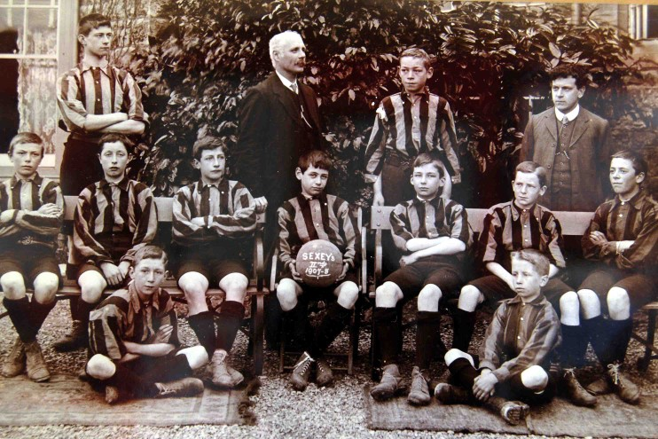

**As can be seen from the details on the ball, this was the school's 2nd team in 1907-8. The boys are accompanied by Mr Smith. (Can anyone put  names to any members of the team? - MJ)**

**This picture of the school's Hockey team (1907/8) was also taken in the same photo session.**

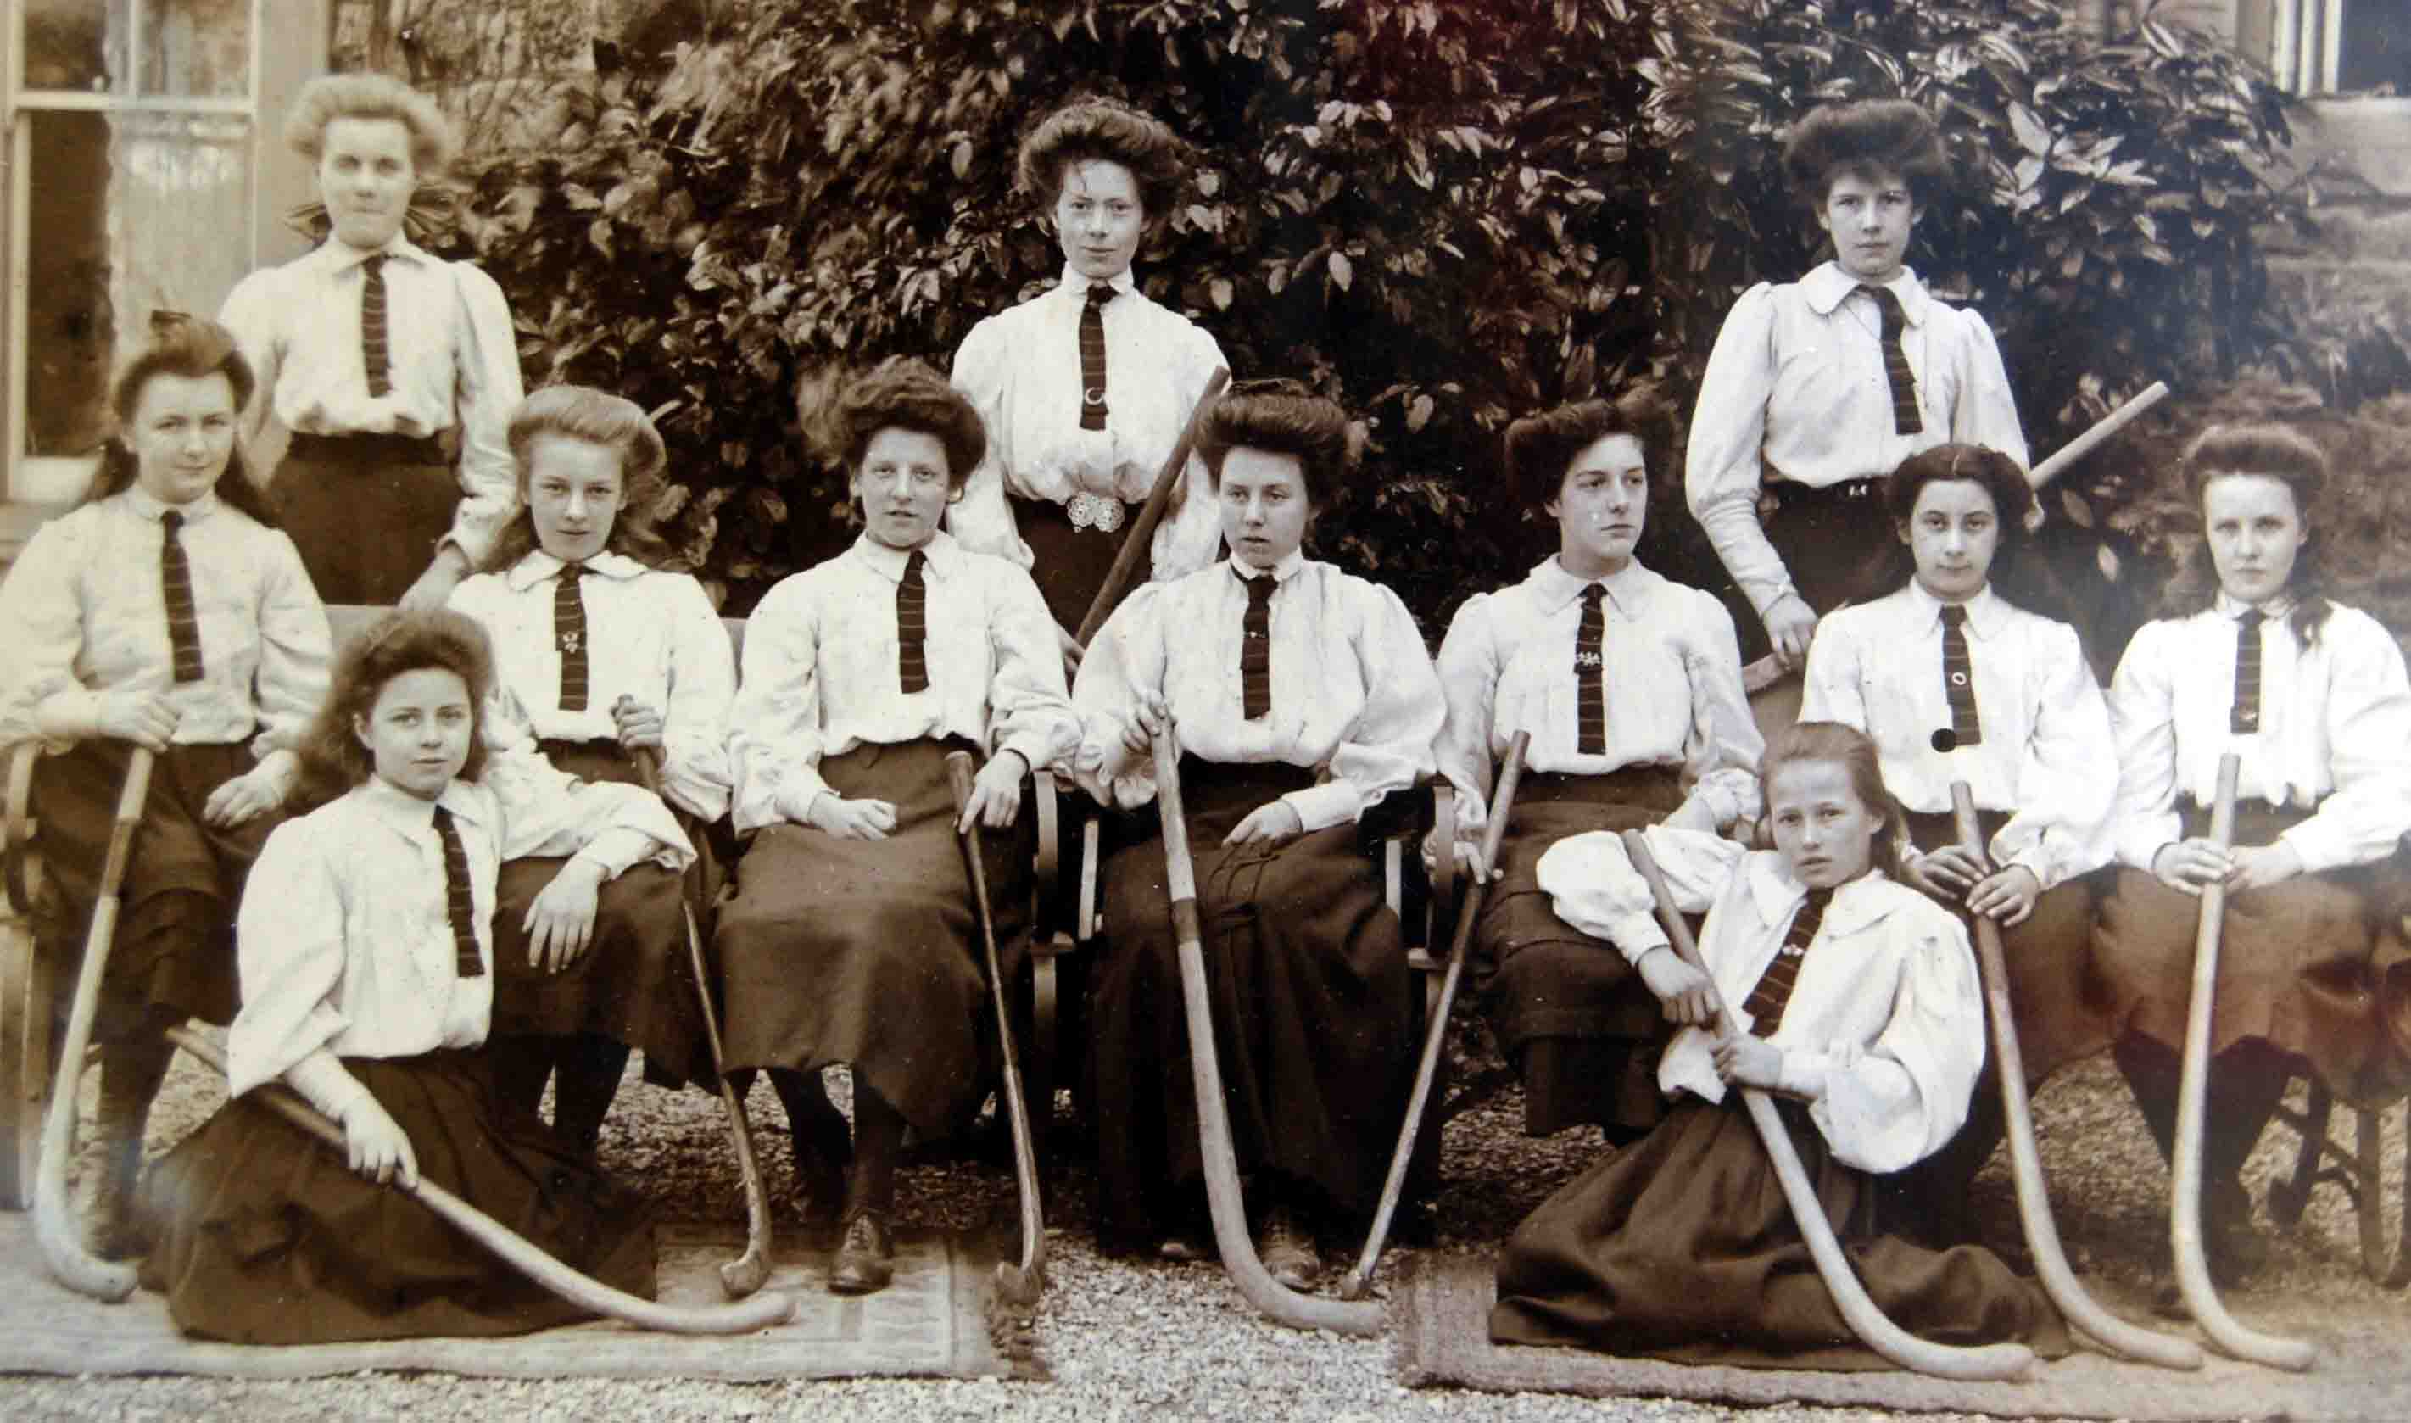

**Not a crooked tie to be seen anywhere- well done, girls!  One assumes that the ties were black and amber stripes - was this their actual playing kit (things *were* a lot more formal then*)* - or was this the school uniform?**

**(It's a sobering thought, that at the time of writing, these photos are exactly 100 years old. Once again, can anyone help with any of the names? - MJ)**

**The snippets of information here, have been gleaned from a number of  sources and can give us a tiny insight into what life was like at Sexey's from its beginnings up to the start of World War 2.**

**The earliest pupil we have information about is Kezia Pine (1888-1982) and this has been provided by Kezia's grandaughter, Jane Evans. Kezia joined Sexey's Blackford as Kezia Goodland in 1901 - the Western Gazette of August of that year records her scholarship achievement. She boarded at the school and was presumably in the hostel building reserved for the girls. Jane tells me that at the time her family lived in Bridgwater and that Kezia was extremely proud of the fact that she had won a scholarship to the school.**

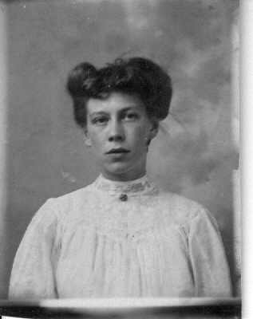

**This picture shows Kezia in her younger days but it is difficult to tell whether she is still of school age.**

**We know something of her time at Sexey's from a diary she briefly kept in 1904 - from the writing on the cover you can see she preferred to be known as 'Kitty'.**

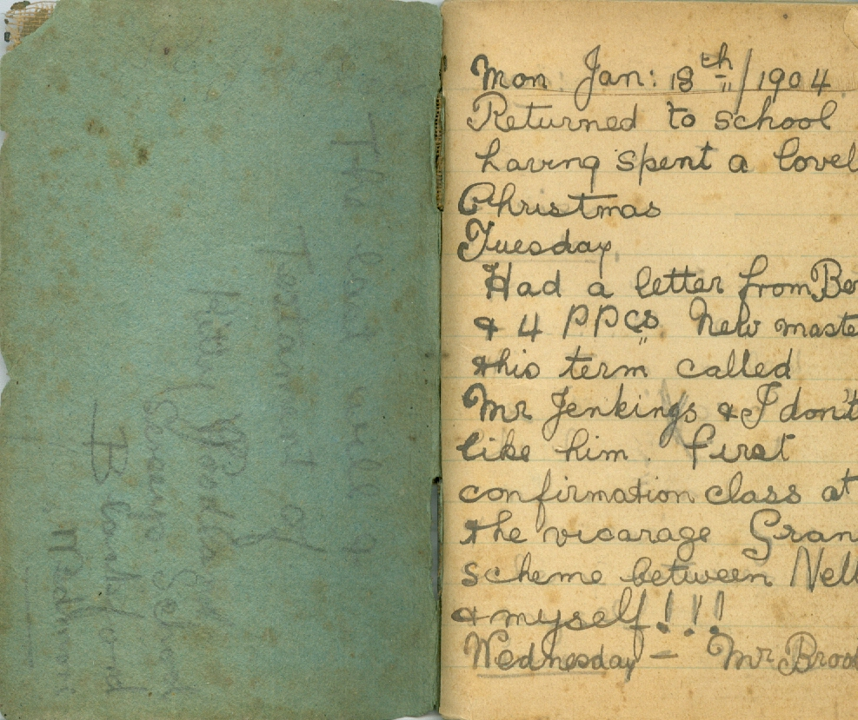

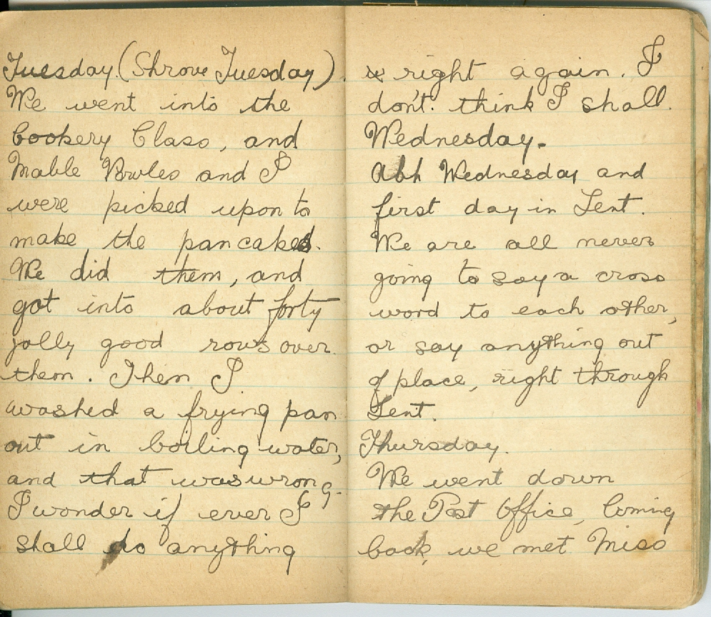

**Kezia took a picture of two of the schoolteachers along with two of her schoolmates.**

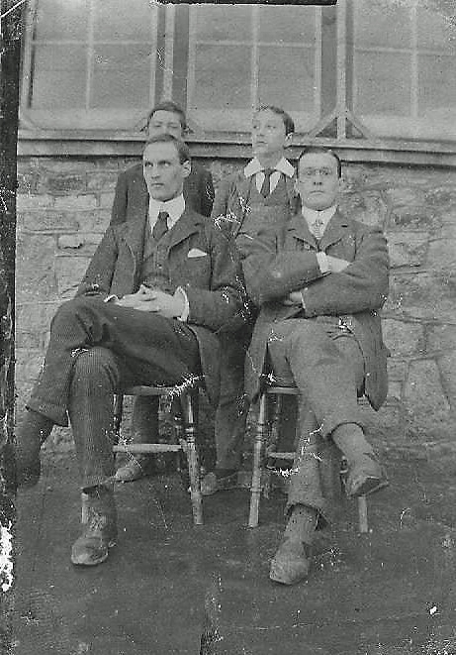

**Kezia certainly has a family that is really proud of her achievments of when she was a youngster  and her great, great granddaughter, Cass decided to write about her as part of her school work. This is what she created. Well done, Cass!**

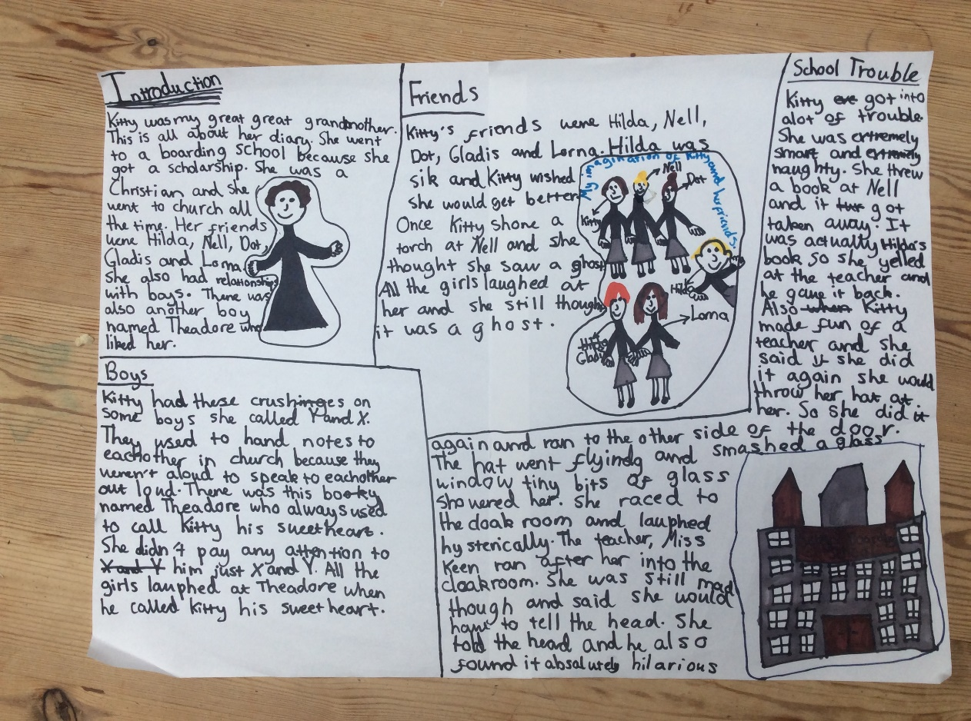

**(Jane, thanks for all the info you sent me I just wish I'd had more space to fit in more of what you sent me - it's been lovely hearing about her as a schoolgirl and it sounds like she really enjoyed her time at Sexey's - Martyn)**

**The 1965 Old Sexonian magazine mentions a character called William (Spider) Tinney who came back to visit the school and had spent most of his life, after the age of 18, in Canada.**

**He was born in 1896 and was 'one of our earliest Old Sexonians'. He was only 3 years old when Sexey's, Blackford first started and therefore, could not have been one of those *very* early pupils who used the Stoughton site.**

**The article goes on to say ' His comment on Blackford and Stoughton was  'No change' '.  Quite what William meant by this is unclear as, obviously, huge changes *had* taken place. Is there anyone out there who can remember this visit in 1965 who can bring to mind any more comments that William Tinney made? Old Sexonian, Joy Morse, has written in to say that 'Spider' was her uncle and that he was a pupil at Sexey's around 1908/9. She says he got expelled for playing football for Blackford when he should have been playing for the school! Joy also tells me that when 'Spider' visited the school in 1965 he found an old wooden desk there with his initials still on it. He also visited again in 1975 with his daughter from Canada. In 1998 there was a Tinney reunion and several of Spider's grandchildren visited the school then. Apparently, whilst out in Canada he taught Eskimos in the Yukon for a number of years and completed his BA at Vancouver University at the ripe old age of 80! Joy Morse attended Sexey's from 1944-48 and still keeps in touch with schoolmate, Maureen Wootton (Slavin) - (Many thanks for the extra information, Joy -MJ)**

**One of the other pupils in the early years of the twentieth century was Rhoda Tripp Day. Rhoda was actually the grandmother of Christine Hoskins (Derrick) who started her schooling at Sexey's in 1966. Christine can remember a few details about her -**

**'Rhoda was born in 1900 in Cheddar and her parents ran the Gardeners Arms pub in Silver Street, Cheddar. She would have attended Sexey's School somewhere between 1910/1911 and onwards.'**

**'I don't know how long she was a pupil there, but I think we could estimate a span of 1911 to 1916. I believe that she used to travel to school by horse and cart, which is probably the transport as described already on your website (the Sexey's brake - MJ). I don't know who else would have attended the school at the same time as her. She was generally a good scholar and did particularly well at French.'**

**On the reverse of this team picture of the 1920/21 first X1 were the names and some additional information-**

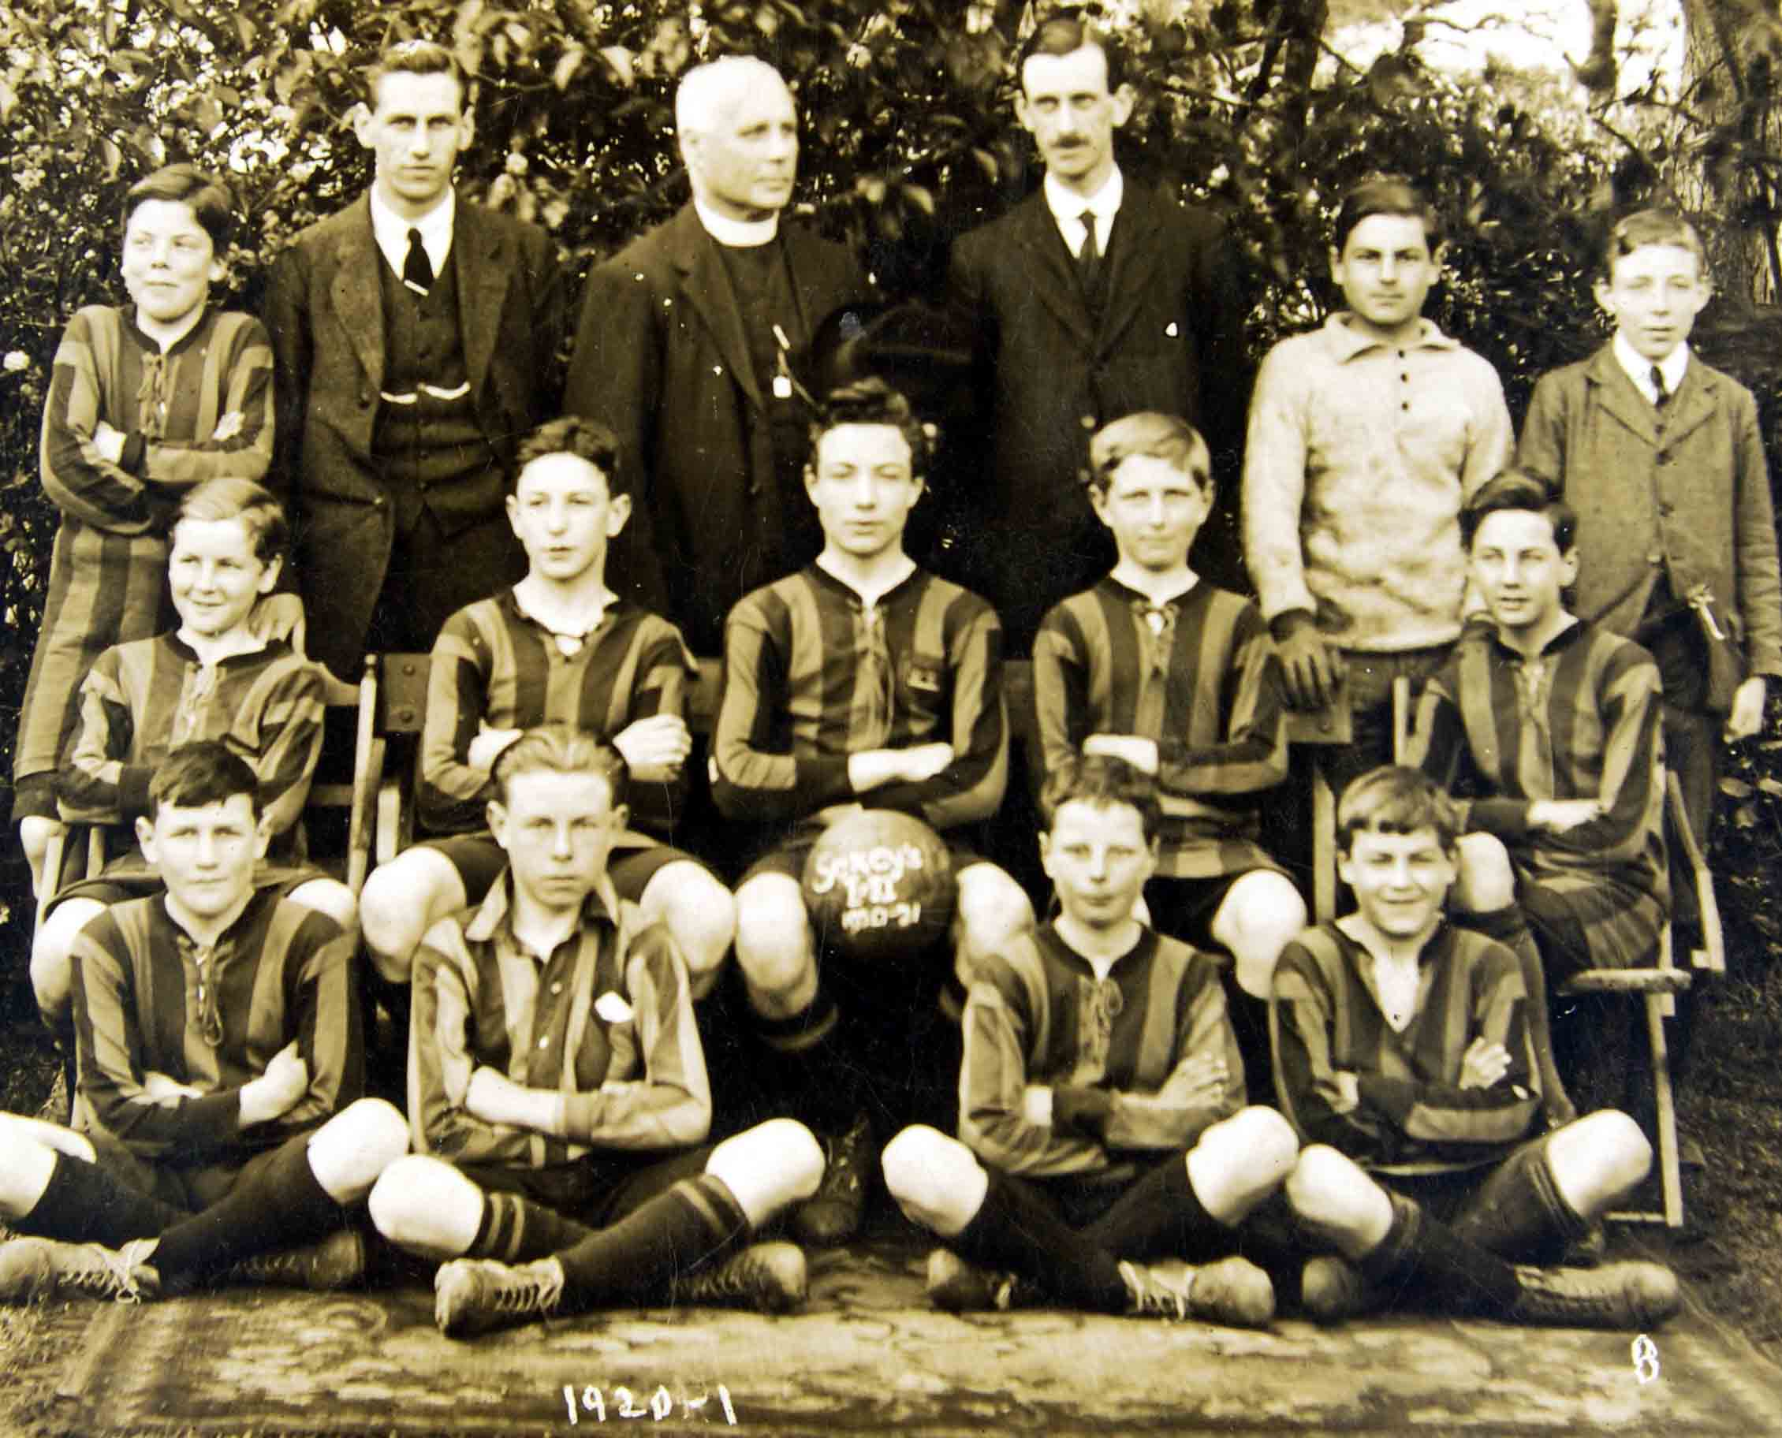

Back Row L-R Bowditch, Mr Passimore, Mr Smith, Mr Bullen, Lloyd, Lynham  
Middle Row L-R R Curtin, ?, J Smith, ?, A Curtin  
Front Row L-R ?, Gibbs, Joe Comer, Lloyd Minor  
'The two Lloyds left for Australia under a government scheme for training young farmers.'

**At some point during his headship, Lawrence Abram decided to have a school prospectus written, in the drive to attract more pupils to the school (loaned by Joyce Huett). This example is the only one I've come across and is something of a rarity. This particular example most probably comes from the late '30's.**

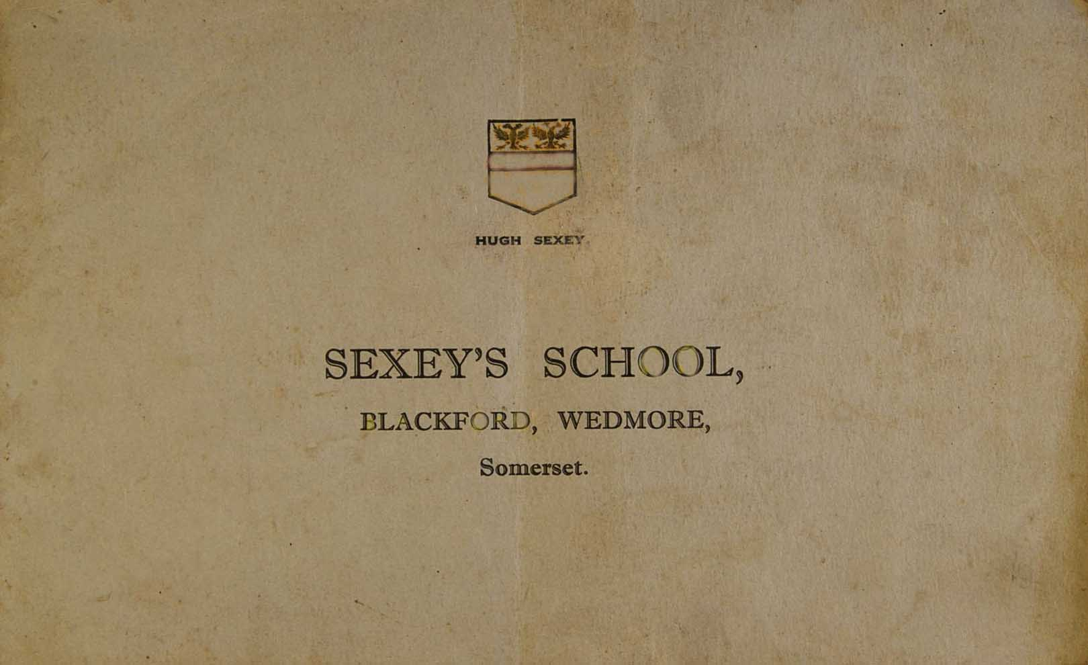

**Inside the grey, front cover is a page which lists the names of  the governors. The school's title used on the inside pages is also interesting, the school being called 'Sexey's School and Sexey's Farm School , Blackford.'**

**Page three shows a list of staff - Lawrence Abram (Headmaster), Miss Thrower (Senior Assistantant Mistress and Art), Mr Evans (English and French), Mr Sims (Science, Book-Keeping and Agricultural Science), Miss Collins(History, Geography, English and Latin), Mr Quarterman (Manual Instruction, Geometry and Physical Exercises), Miss Williams (Domestic Subjects, Hygiene and Physical Exercises), Miss Bruford (Music Mistress), Mr Carter (Violin and Singing) and Miss Paull (Preparatory Mistress).**

**In the 'General Information' section as well as the usual classrooms being mentioned it also states -  'There is a miniature Rifle Range which is used in conjunction with the School Cadet Corps.' It also mentioned the Farm School where - 'pupils over the age of 14 years wishing to take up an agricultural career can have excellent training under fully qualified teachers.'**

**Page six shows a photo of the dining hall next the 'Boarding Arrangements' page. Here it states -  'The district is bracing, and the boarders get more freedom and 'out-of-door' life than would be possible in any town school.'**

**Over the page is a photo of the Hostel. Next to this it states the tuition fees and Boarding fees. For tuition, all Somerset children had to pay £12 per annum. For boarding it would cost £40 per annum, you could board 'week days only' for £34 pa.**

**Page ten shows a picture of the girls' sitting room in the hostel. This and some of the other photos mentioned are included here -**

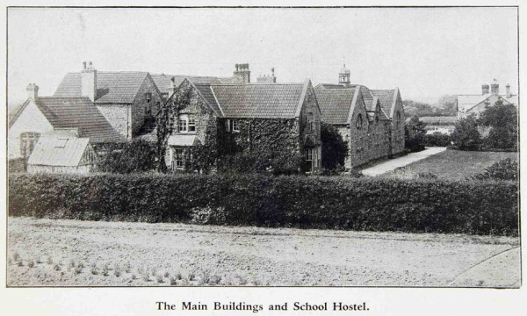

**On 'this' side of the hedge can be seen rows of vegetables which were probably tended by the 'farm pupils' presumably used to feed the boarders. Hubert Fisher tells me that his father used to till this ground at the time and that his mother and aunty (Amy and Florry Stevens) used to work in the kitchens.**

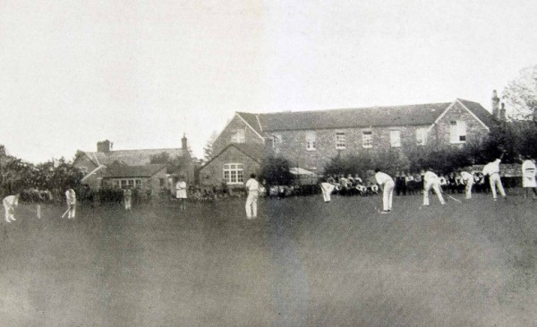

**Probably a 'House' cricket match. the building to the left is the Armoury.**

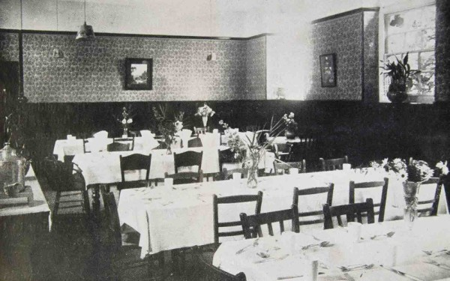

**The Boarders' Dining Room - it never looked like this in the 1960's! This must be at the 'new' hall end - tablecloths and wallpaper, very posh!**

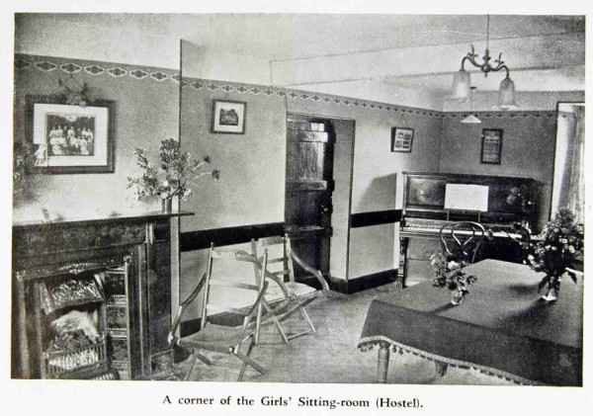

**Does that wonderful old fireplace still exist today, I wonder?**

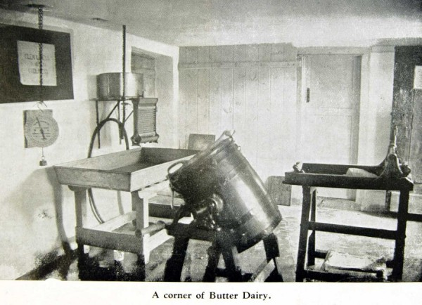

**Some children at the Farm School went on to the Farm Institute at Cannington, near Bridgwater.**

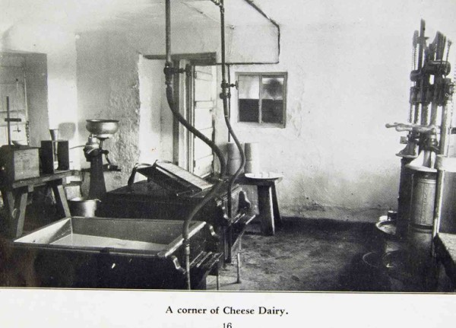

**The Farm School certainly had the equipment but I expect it was chilly in the middle of Winter!**

**The prospectus went into detail about he various courses at the school and farm school. It finishes with a section on the Preparatory school -  'The inclusive fees are £12 per annum. As the number of pupils admitted is limited, the children receive individual attention from a specially qualified mistress.'**

**In 1930 (it may have been 1931!), Sybil Starks joined the school via a scholarship, obtained at the local Council school (later to become Blackford Primary School), her sister having been through the Farm School some five years earlier. joined the school as a day pupil. Sybil recognises herself and a number of her friends in the 1933 whole school picture which can be seen a little further on on this page. (Sybil is actually standing directly behind Miss Thrower who is the 4th teacher from the left). The friends that Sybil has named will later appear in sections of the 1933 photo which will appear in the 3rd of the General picture galleries.**

**She remembers her time at the Council school particularly well and she recalls a Mr Phillips who used to teach there. She was convinced he had suffered 'shell-shock' during World War 1 as he would occasionally be very cruel with the use of the cane, particularly with the boys. In later years he could remember nothing about it and was astonished to hear of the cruel punishments he'd meted out. Mr Phillips ran a 'night' school for woodwork and his wife helped with dress making and leather work.  
  
Whilst at Sexey's Sybil cannot remember having to change rooms for a single lesson, the children had their own desk and the staff came to them. She remembers disliking the French teacher, Mr Evans. Apparently, he was very strict and would always expect pupils to say 'Good day, Mr Evans' if ever they saw him out and about - you were in trouble if you didn't!**

**Sybil said she had very little contact with Mr Abram personally but that her brother Jim was occasionally sent to him for the stick! She remembers Mrs Abram as being 'a dreadful woman' who looked after the boarder girls. She also remembers the Abrams' daughter Elsie who was a 'clever girl'.**

**Interestingly, in the 1930's Sybil's father purchased the property in Stoughton which had been used some thirty years earlier as Sexey's school whilst the present building was being constructed. This was to become her family home and she can remember the house and barn as well as Cedar and Weeping Willow trees in the grounds.**

**Sybil tells me she left Sexey's at the age of 16 and took up tailoring at a shop in Wedmore.**

**(Thank you, Sybil for all those memories and many thanks to Ann Amesbury for arranging the interview).**

**It's always surprising what you can find on the Internet (not all of it wanted!). Recently, a casual Google search one Sunday morning (followed by a few pieces of detective work) led me to discover another Old Sexonian who had been a pupil  way back in Mr Abram's time.**

**Having carried out a search using some key words, not really expecting to find anything, about ten Google pages down the line I discovered that - 'Mary Rose Baker was born in Somerset in 1921. She was educated at Sexey's School, Blackford, as a boarder.'**

**This happened to be the 'blurb' on the back cover of a book that Mary had written, one of three in fact. As the book related to living in the South-West I decided to order it ('Exmoor Interlude') to see if Mary had included some details of her time at Sexey's. Unfortunately, this wasn't to be as this turned out to be Mary's last book to date and included much of her later life.**

**Not to be put off I looked through the book (which is a really good read) and found a mention of 'Karen', one of Mary's friends who had set up the animal charity, 'Bristol League for Cats'. Fortunately, the charity has its own website (http://blfc.weebly.com) so I sent off a speculative email, not really with any high hopes but two days later I received a reply with a contact number for Karen. To cut a long story short, Karen very kindly set up a meeting with Mary (who only lived 25 miles away) which has led to this article being on the screen in front of you now.**

**Mary Baker joined the school as a young schoolgirl in the September of 1932, as Mary Dodge. With her family living in Bristol, Mary was to become a boarder at the school for the following five years, leaving in the summer of 1937.**

**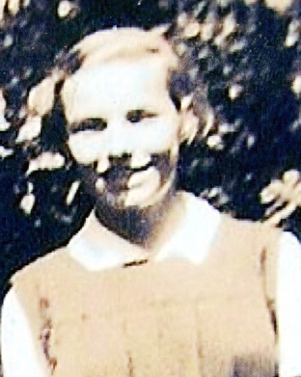  Mary Dodge (Baker)**

**(Mary's boarder memories can be found in the 'Boarders' section of the website and give us a fascinating insight into boarding in the 30's.)**

**One of Mary's schoolroom memories relates to the arrival of a new, male member of staff at the time - ' A new teacher was introduced to us one day. He was youngish and very nervous and we didn't take to him, so we decided to play a trick. His desk was on castors, so one day we brought in a roll of string and tied some to the two front legs. He came in, sat down and then stood up to write on the blackboard, with his back to us. We then pulled on the string to move the desk forward a little! He sat down but couldn't quite reach the desk so had to move his chair nearer. The second time this happened he turned very red and went out of the room. When he was gone we hastily removed the string expecting the headmaster to turn up but only the teacher returned. A week or two later he left the school. I feel really ashamed thinking of this now. Poor man!' (If he couldn't cope with an innocent trick like that, then teaching probably wasn't for him anyway - MJ)**

**'The five years I spent at Sexey's were the happiest in my life. The eventual leaving was almost unbearable but I was able to keep in touch with many special friends which certainly helped.'**

**In 1933 Mary was presented with a leather bound copy of the complete works of William Shakespeare, signed by the Headmaster.**

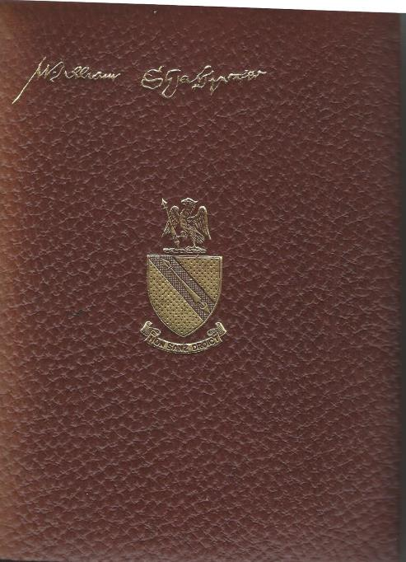

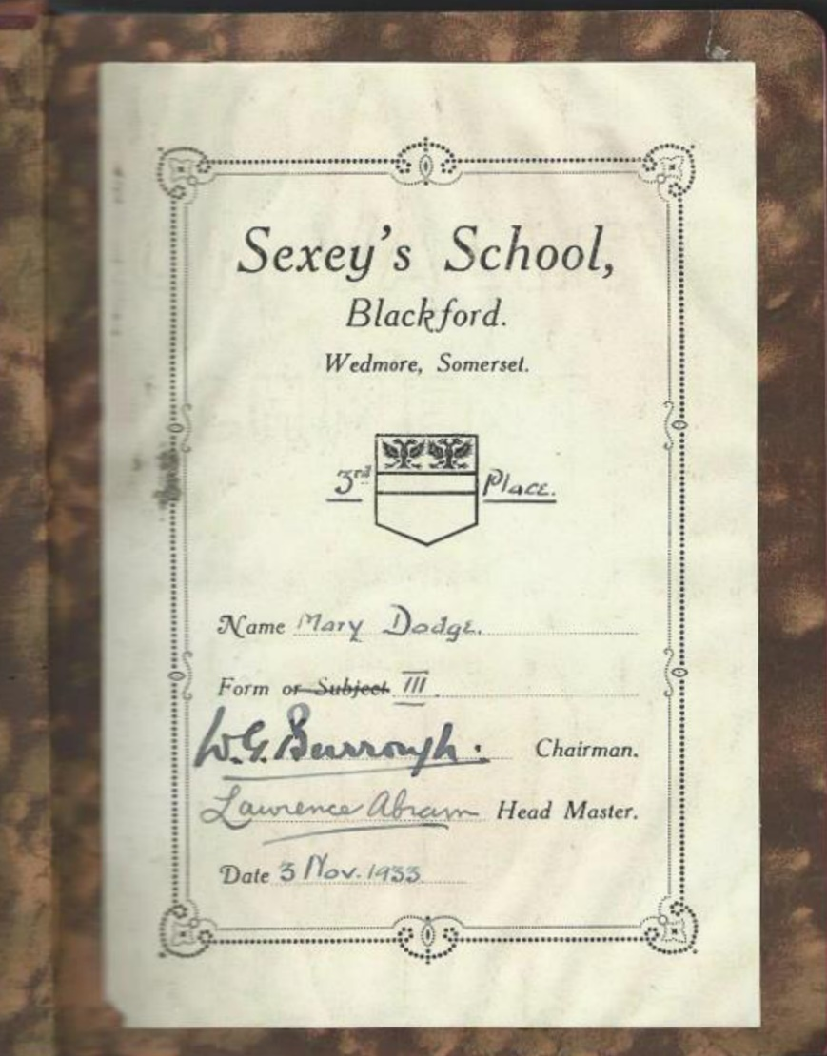

**(Something that I still find amazing is that despite a difference of thirty-two years between our starting dates at Sexey's, Mary and I were both taught English by the same teacher - namely, Erica Padfield!- MJ) Mary can remember Erica starting at the school in 1935 - 'she seemed very young and absolutely beautiful, the older boys were totally smitten with her.'**

**Interestingly, Erica's father was the headmaster of the Blackford Board School (the old Blackford Primary School building) at the time.**

**Erica died in 1971,which was my final year at the school. There can't be many people, in whatever profession, can say they spent 36 years at the same establishment - good on you, Erica!**

**Mary can remember a number of the pupils' names from those days. These were Madge and Sarah Alvis and their brothers, Myra, Christine and Reg Wilkins, Joyce* and Gweneth Blake, May Trask, Betty Smewin, Monica Cox, Cicely Young, Janet Pierce, Marjorie Hutton, Dorothy Parr, Grace Chammings, Heather and Daisy Waite, Beryl Gunstone, G Curtin, Jimmy Clapp,? Heywood, ? Bailey, Donald Harris, Vivienne Gray, Alec and Donald Moore and Max Puddy. She also remembers the Jesty twins, Peggy and Betty. In Joe Foster's article, further on in this section, they were referred to as the 'Jolly twins', this must have been a play on words.**

**\* Recently the daughter of Joyce Blake has written in and kindly given us some more information about her mother -**

**'I came across your website by chance - I was wondering whether the school Mum went to (and, to her irritation, my siblings and I in our ignorance always joked about, being rather tickled by the notion of a mixed boarding school called "Sexey's) still existed, did a Google search and - eureka!  
  
'It was really interesting to read the school's history and of course I was most taken with the period during which Mum was there, as related by Mary Baker (and the photographs).'**

**'The school was very important to Mum. She and her younger sister (Gwyneth, known as "Gwen") had not been allowed to go to school - or even to play with other children - and she had no formal schooling until the age of 10, when she (and the following is quoted from a letter to my brother) "made a tremendous fuss and insisted on being sent to the local county secondary school which officially only took 11-18 year olds. I was extremely happy there and was promoted to the second year after 2 weeks, so joining the twelve year plus age group." This was Sexey's.'**

**'She went on to Clifton (I think, the High School), took up sciences in her final one or two years there (she was filing in time, having done her final school exams but being too young to go on to university) - and won a place at Bristol University to study medicine. Following graduation, she specialised in pathology and stayed in this area until she met Dad (Alexander "Alec" Persey), in the late 40s, through a mutual friend (Dad, also a doctor, was working in Bristol at the time), moving up to Halifax in 1950.'**

**'They married in 1952 and settled in Long Eaton, Derbyshire in 1955, where Dad established himself as a general practitioner. Mum helped him out in the early days, and did locum work for other practices, before moving into paediatrics, which she continued with until retirement. She had three children - 1954, 1958 and 1964 - and she and Dad lived happily together in the Nottingham area until her death in 2009 (following a major stroke in 2008). Dad died 17th January of this year - end of a era.'  
  
'Anyway, I am not sure whether any of this is of any interest, but I had intended to contact you before Dad died and just didn't get round to it. For me, and for my older sister and younger brother, it is always humbling, but also inspirational, to think about how much she achieved at a time when it was really tough for girls to succeed academically, particularly given the slow start to her formal education. She had a brilliant brain, was very sporty, had a mischievous streak - and always regarded Sexey's with great affection, so I just wanted to let you know.'  
Regards  
Janet Persey   (Thanks for taking the time to write, Janet - MJ)**

**I would like to thank Mary, her husband John (particularly for the tea and chocolate biscuits!) and daughter, Maggie for providing me with the pictures and memories that have gone in to making this article - MJ. (Remember, Mary's boarder memories can be found in the 'Boarders' section).**

**This 'whole school' picture was taken in 1933 and shows all the school staff at the time, together with some of the pupils.**

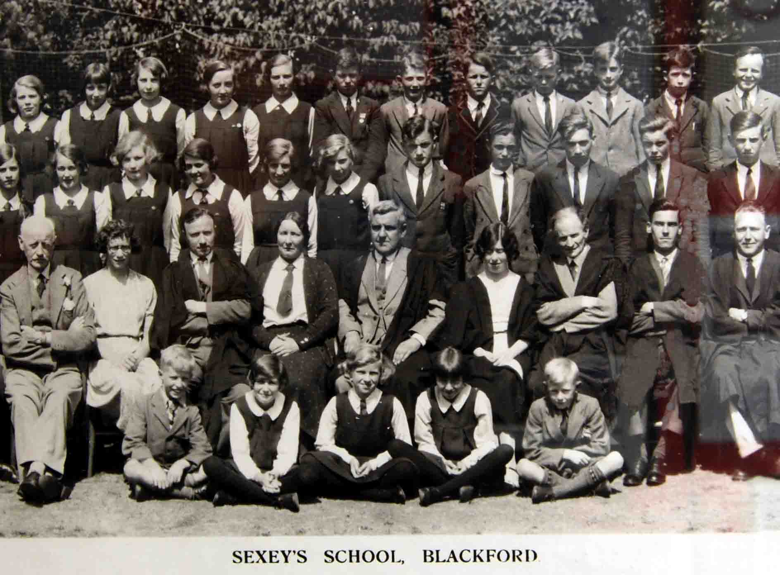

**In the centre, between the two ladies, is the Headmaster, Lawrence Abram. Mr Abram was in his tenth year at the school when this picture was taken. Mary Baker, who was a pupil at the school at the time but unfortunately does not appear in this portion of the photo, tells me that the male member of staff on the extreme left is Mr Carter, next to him is the Kindergarten teacher and then Mr Evans (French) followed by Miss Thrower. To the right of Mr Abram is Miss Collins. Mary was able to identify the girl in the 2nd row standing, on the extreme left, to be Joyce Blake. (Fortunately, I was able to return to the school and re-photograph Mary's photo and make a selective enlargement showing her with some of her classmates) -**

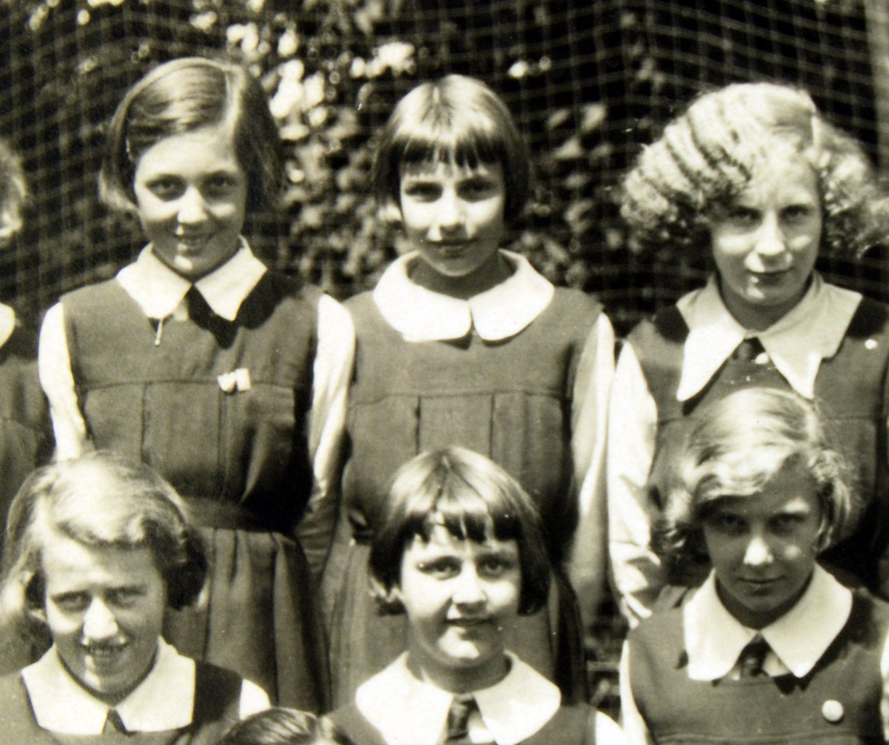

**Mary is the child in the middle on the back row.**

**It's always nice when photos on the site, particularly the older ones, generate more information. On seeing the photograph from 1933, Michael Nicholson emailed me the following -**

**'Just to update that in the 1933 picture of the 'whole school' the rather glum looking boy on the back row second from the right with dark hair is my late father, Edward George Martin Nicholson - always known as George. He attended the school on a scholarship awarded to him and his widowed mother. I also attended the school during the 1960's - 1970's as did my brother.'  (Thanks for the extra info, Michael - I remember you and your older brother, Pete, who was one class ahead of me - MJ)**

**Another pupil of the 1930's was Joe Foster. His name first came to my attention as he is one of the names on the Sexey's 'Roll of Honour' board, written there as 'JGW Foster'. Whilst studying the 1966 'Sexonian' magazine for interesting snippets, I came across the 'Generations' section. In this section someone had compiled a list of names of pupils who were 2nd or 3rd generations of their families who'd attended Sexey's, complete with names and dates.**

**Written next to 'Geoff and Patsy Thorne' (whom I know very well and attended Sexey's with me in the '60's and '70's) was the following  -  'Uncle, JGW Foster,c 1935 (died in the 2nd World War).'**

**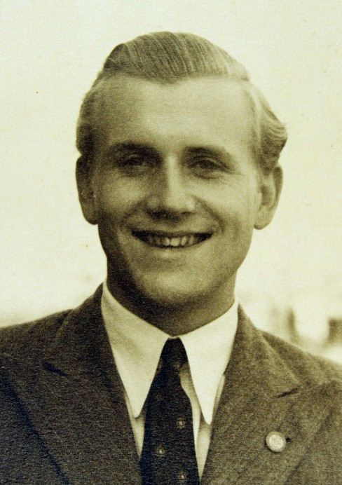  
Joe Foster**

**A quick phone call to Geoff verified that these details were correct and he set up a meeting between myself and Joe's sister, Pam. This meeting was to produce some really rare and interesting items for the website.**

**One of these items was a 1934, 'Sexonian' magazine, the oldest on the site to date - needless to say the details of this mag can be found in the 'Old Sexonian Magazine' section. This issue had some very interesting features and it's definitely worth a read.**

**One of the other items that Pam produced from Joe's belongings was a picture taken in the school grounds of Joe's classmates, featuring Mr Abram himself.**

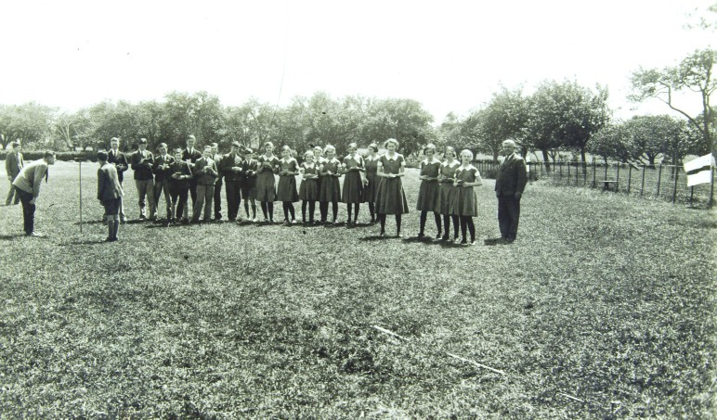

**The rarity of such a shot shouldn't be underestimated. It's one thing having an early team or class photo, for instance, taken by a visiting proffesional photographer who will eventually produce lots of copies, but it's quite another to come across a 'one off' informal shot taken by a pupil who happened to have a camera with them at the time. Pam tells me that Joe doesn't feature in the photo with the rest of his classmates so he must be the one actually taking it.**

**It looks like the group are doing some amateur surveying or something similar - look closely in the grass at the front of the picture and you'll see a small datum post with a measuring tape attached, which runs towards the 'instrument' that the boy is using. On the right hand side appears to be a target or flag on the fence - did this feature in what the class were doing? (Answers on a postcard, please ....MJ)**

**Just in case anyone has any information about this class of children, I've enlarged the female group besides Mr Abram, to try and make the girls more recogniseable, which will hopefully help to jog some memories.**

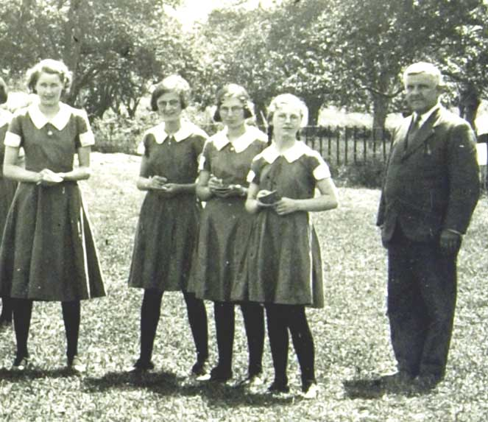

**Apparently, Joe used to mention the 'Jolley twins', two of the girls at the school, but they may have been in another class.**

**Another item that Joe's sister was able to show me was his school report. This showed him to be a pupil of above average ability - his 'general comment' was 'Very good:Has worked well'. This was signed by by HS Williams and Lawrence Abram.**

**A closer look revealed that Joe was 'excellent' at French. Interestingly, subjects like 'Agricultural Science', 'Book Keeping' and 'Dairying' also appeared on the report.**

**Joe was obviously very keen on flying as he joined the RAF Volunteer Reserve on the day he was 18. He became fully qualified as a a pilot in 1941 and was posted to the Coastal Command Strike Squadron.**

**Here's Joe in uniform.**

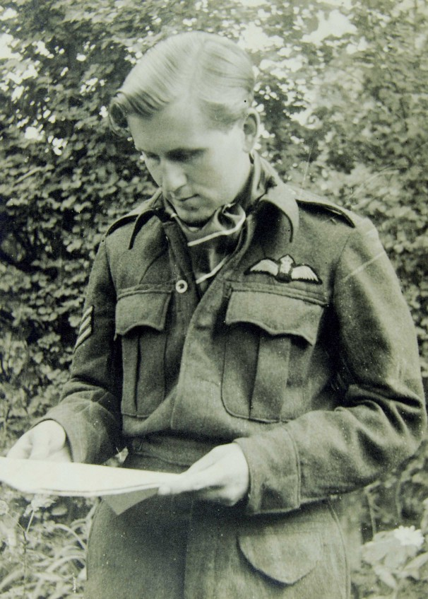

**Tragically, Joe, by now a Flight Sergeant, was shot down and killed on May 1st, 1943, aged 21. Joe left a wife, Margaret. He was buried at Sola in Norway in a Commonwealth War Graves Commission cemetery.**

**On Remembrance Day, 1952, families of past pupils who had died in wartime were invited to the school for the unveiling and dedication of a war memorial. The names of all the pupils commemorated were read out.**

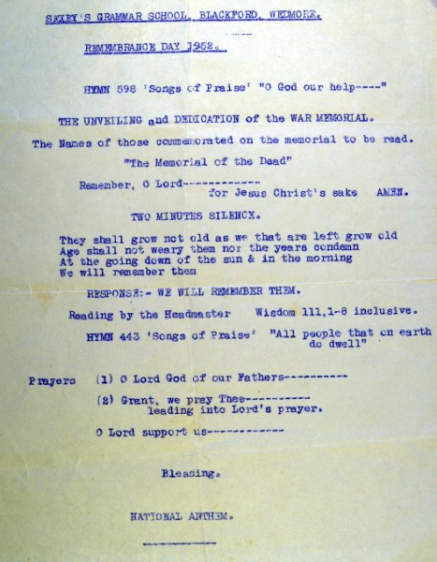

**Joe's sister, Pam, seems to think that the memorial was a lectern and not the large wall 'board' used presently.  
(Does anyone else have memories of that special day? - MJ)**

**(It has been a real privilege to cover Joe's 'story' and I would like to extend my thanks to all members of his family who have made this article possible. It outlines the extreme bravery shown by many 'old sexonians' and the ultimate price that some of them paid. - MJ)**

**Bob Bryant joined the school as a pupil in 1935 and finished in 1940.  Bob remembers a number of the other pupils, these were Norman Cook, Jack Bates, Stuart Vowles, Phyllis Gray, Ron King, Mary Robinson, Vernon Stephens, Stanley Williams, Graham Tripp, Percy Jubin, Max Trimmer and Joe Foster. He fondly remembers Dorothy Hassell who was his girlfriend . He remembers that she was two years younger than him and lived in Weston Super Mare. She boarded at the school and he often cycled from Berrow to see her.**

**Bob remembers taking sandwiches for lunch except on a Friday when the Bertorelli's chip van (from Burnham) used to turn up at the school - around a dozen pupils had ' fish and chips'.**

**Bob had always wanted to join the RAF but started his working career in one of the laboratories at the Royal Ordnance factory, Puriton where he got promoted to 'chemist'. Bob decided he still wanted to join up but unfortunately he badly damaged his arm during initial training. After six months he was sent to an aerodrome in Northern Ireland. Eventually, Bob got into the RAF but not as part of an aircrew - he retrained as a clerk carrying out special duties at Middle Wallop fighter station. He was demobbed in 1947 and worked in the offices for a firm of builders. (thank you for letting me interview you in your home, Bob . MJ)**

**In 1936 the Weston Gazette covered the school's prizegiving evening and includes a photograph showing the Prebendary TF Palmer and Beryl Gunstone receiving the Girl Guide shield for Sport. In the article Palmer outlines his anti-examination beliefs - ' I am sure we are heading straight for disaster by attaching too great importance to examination results'. (Unfortunately, I don't think too many people were listening, sir!! - MJ)**

**By this time Erica Padfield had barely been at the school a full year and we can see from the article her duties included the organisation of the Girl Guides.**

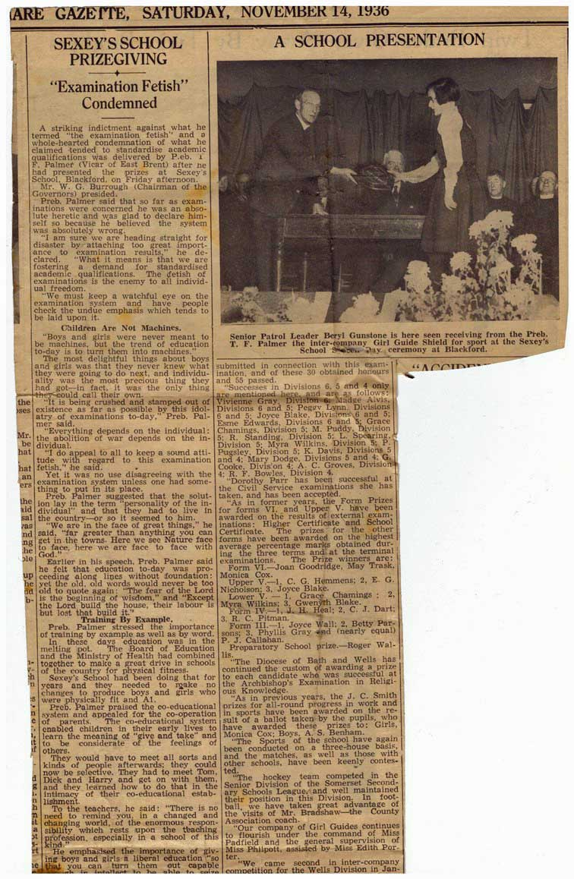

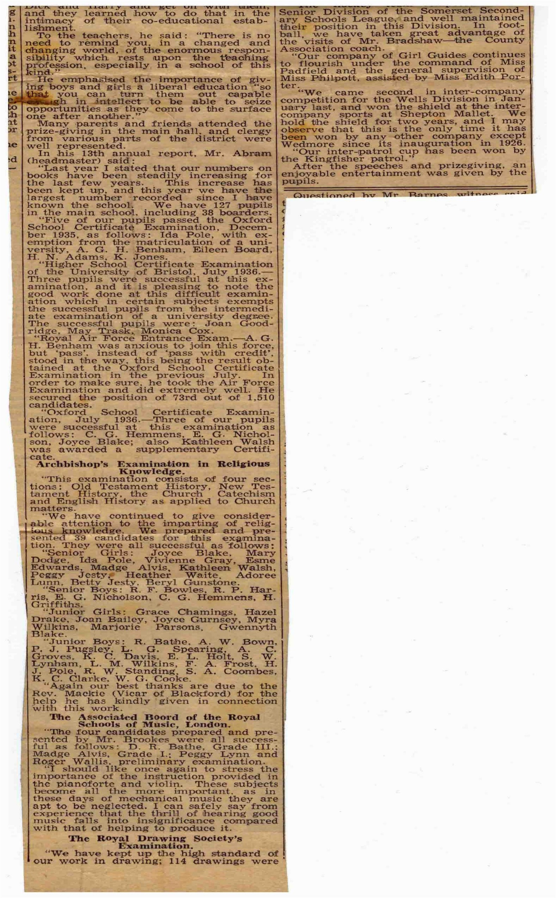 **(Many thanks to Pete Nicholson and John Grant)**

**It would be another three years before Henry Tomlinson took the helm -**

**On September 1st, 1939 Henry Tomlinson became the third Headmaster at Sexey's. In one respect he couldn't have chosen a worse date to take up the reins as it was this very day that the Regent Street Polytechnic School of London decided it would evacuate no less than 440 boys to the West Country, many of them to Blackford! Needless to say, Mr T took charge of the billeting of the local evacuees - this was just hours after his arrival!**

**We are very fortunate that the Polytechnic had its own school magazine called the 'Quintinian' and that many of the evacuees were able to write first hand accounts of their time in the West Country. (At this point I must thank the school, now called the Quintin Kynaston School, for allowing me to use these extracts from the magazine in their entirity. Thanks must also go to John Grant for seeking out the staff members concerned.)**

**Here then are the extracts, as they appear in the Quntinian, of nine of the evacuees that turned up in Blackford. They didn't stay in Blackford for too long as it was decided that there was more appropriate accommodation in Minehead. They must have enjoyed their time in Blackford, though, as a number of them decided to cycle back to Blackford to pay a visit - quite a journey!**

**C. NABARRO (U.5Ai) arrives at Blackford - 'After having watched the train slowly puff out of Cheddar's small station, we remained for a time under its roof in order to shelter ourselves from the steady downpour of rain, which had persistently followed us from London. Fortunately, for us, in a short time the rain eased off considerably, and so we moved off in a long "caterpillar", headed and punctuated half-way by our large banners.'**

**'The procession proceeded through Cheddar, and was watched by the entire awe-struck population. Without any incident of importance we arrived at the end of the town, and were all much cheered at the sight of a new cinema nearing completion!'**

**'We then divided into our squads, and prepared to board the coaches which were waiting to take us to one of four small villages, all of about five miles distant. The task of boarding was by no means pleasant, as we had to enter with all our luggage, and by this time the rain had added to our difficulty by returning once more in far more ferocious mood. However, we eventually managed to get our squad on board the second coach, and, amid cheers, we made our way through avenues of less fortunate boys who were still waiting in the deluge.'**

**'The coach was most definitely not a 1939 model, and it gave one a feeling of holding on to a road drill as it ploughed its way through the murk on its long journey to the little village of Blackford. The long, narrow, winding country road shone with rain as it stretched far off into the mist, and on each side for as far as the eye could see were the hills, assuming purple hue in the fading light.'**

**'After about half-an-hour we drew up outside a small building, which had the title of Blackford Council School. Then came the pleasant task of disembarking in the merciless rain. We slowly came out from under the barrage of cases, which we had placed on our knees, and slowly but surely reached the warmth of the quaint little school-rooms. Here we received a very warm welcome from the persons who were to attend to our future welfare, and their first job was to present us with our emergency rations. These were received with no little consternation, and it could be plainly seen that some doubted very much whether they could (should the emergency arise) last out on the contents of the parcel for two whole days.'**

**'Then came the colossal job of the actual billeting, and much credit must be showered on the billeters for preventing a minor chaos when the question arose as to "Who goes with whom?''. Several of the persons connected with the billeting possessed motor-cars, and this aided the job of distributing the boys very considerably, and in a time much shorter than all had anticipated we reached our billets.'**

**'My "billet companion" and I were very lucky in being selected for what turned out to be the billet of the area, and we did not have long to wait at the School before being whisked away in a car to our new home. Here our hearts sank as the lady of the house assumed an expression of surprise and horror at the sight of us, dripping wet and laden with bags, as we presented ourselves at her doorstep!'**

**'Her dismay, we learnt later, was due to the fact that we were supposed to be "children of 4 or 5". But she soon recovered, and we were welcomed with a huge meal which satisfied our hunger, which by now was telling us that it was a long time since lunch! Then, relaxing in a spacious arm-chair, I looked back over the eventful day of travel.'D. C. JONES (4A) gives his general impression of life in Blackford.**

**'It did not take us long to settle down in our new home, an old but very comfortable farmhouse, or to the strange surroundings. Everything was so different from London - no buses, trams, or motor-cars tearing to and fro, but just an occasional clip-clop and rattle of a horse and cart passing along the road, and the whirr of the reaping machine in the fields.'**

**'Each morning, as you walked into town to report, everybody you passed said "Good morning", or passed some comment on the weather, whether they knew you or not. Most of us found a lot of things to do to help pass away the time, such as helping the farmers in the fields haymaking, and later still, just before we left, making cider.'**

**A MARSHALL (4A) adds-**

**'The village of Blackford consisted of one main street, with about three side streets. There were four shops - a general store, two sweet shops, and a butcher's - besides a public house. If anyone walked for five minutes in one direction they would come to country. Everybody seemed to know everybody else, and the whole village seemed to share three names, notably Duckett, Starr, and Wall.'**

**'When we arrived at Blackford we were just in time for the blackberry season, harvesting, and apple crop. Those boys who worked on a farm were lucky to be able to have as many apples as they wished. The others, however, had only to ask and could have as many apples as they wanted.'**

**D. SELIGMAN (3B) gives a general idea of life there -**

**I was billeted on a farm and I think it was about the biggest farm in the district. Farm life I enjoyed a lot, and I was quite busy haymaking, driving the horse and cart, and nearly every evening I used to go round the various fields collecting the eggs, and that stretch was about 1½ miles.'**

**'Driving the cows was another thing I enjoyed, but they certainly kept you on the run. I had also the regular job at the School of feeding the chickens for the Head Master, so, you see, I wasn't idle.'**

**T. BAYNTON (U.5Ai) has adventures among the chickens -**

**'On returning we met the farmer's son, who was going out to feed the chickens, and we asked him if we could accompany him. He told us we could, and, if we learnt how to feed them, we could do it ourselves next time. He opened the gate of a field, and when we had all come through he told me to shut the gate again. While walking across the field we could see one hen pecking about near its coop, and it set up a terrific cry on seeing us and ran and flew about. All the others heard this and came as well. Their meal was wheat, and it was thrown to the ground, and while they pecked at it we went off to collect the eggs. We went into the coop and climbed over their roosts to the nests and collected all the eggs, except for a few a hen was sitting on. Every time I tried to get the eggs away, she pecked at me, so I asked the farmer's boy to do it. He knew just how to deal with the hen. He threw a handkerchief over its head and held it there while he got the eggs, which amounted to 32 when we had finished." Tea was ready for us when we got back, and it consisted of two eggs each, bread and butter, and cake. We had two eggs for tea nearly every tea-time. We always found something of interest on that farm and were never idle until the day we left.' H. S. BROMBERG (L.5C) tries, not too successfully at first, to milk a cow -**

**'One day, just before tea, the farmer asked me if I would like to see him milking cows. When we arrived at the ground where the cows were, we got out of the car, unloosened the churns, put them on the ground, and fixed a strainer on one of them. Then we said to Rover, the dog, "Up and get them, boy; hope, hope, hope." When all the cows were rounded up together I asked the farmer if I could milk one. So he selected the quietest cow he could find and put the span on her legs to hinder her from kicking.'**

**'Then I put the bucket under her, sat on a stool, and tried to milk, but I couldn't get a drop out of her. So the farmer told me to wet my hands. I went across to the ditch and dipped my hands in and, to my surprise, they roared with laughter, because I was supposed to wet my hands with milk. When I had done this I started to milk the cow, but just when I was getting on nicely the cow calmly walked away, knocking the pail over in the process. Luckily there wasn't very much milk in it.'**

**V. STEEDON (L.5C) writes a thrilling narrative entitled -**

**'A COW WITH MILK FEVER'**

**When I was at Blackford I was on a farm called Lime Kiln Farm, because on the land was a lime quarry which was used till 400 years ago. This is, however, sidetracking the real story. The farm was only a moderate sized one of about 24 acres. Fifty chickens, two large orchards, a herd of 10 black thoroughbred Dexters, two horses, and two calves comprised the whole.'**

**'About the second week Mr. Tinney, the farmer, had two cows, Sarah and Bertha, which calved. Sarah had calved at 3.15 p.m., and at about five o'clock Mr. Tinney began to get worried about her, for she began to wobble on her legs. He suspected milk fever, so he rang up the vet. Unfortunately, he was out, but he would be round as soon as possible.'**

**'Mr. Tinney had some sacks filled up with earth, the use of which I will relate later. Then he told me to keep an eye on Sarah while he went milking, as it was long over-due. The dog, Jeff, rounded up the other nine cows into the next field and Mr. Tinney began to milk. He had told me that if Sarah, who was lying down, attempted to get up I was to call him. She was all right for about ten minutes, then she managed to get up. Calling Mr. Tinney,for she looked as if she would roll into a ditch, I told the dog to go back to the farm as he was getting too curious." Mr Tinney soon came, and when he did he held Sarah by the horns and pulled her about two feet. Then she flopped down. She went down as a camel would kneel, then she rolled on her side. Mr. Tinney had a long iron stake handy with a length of rope. He drove the stake into the ground and tied Sarah to it. He asked me to bring over the wheelbarrow with three sacks full of earth in it. I saw the use of them then. He put them under the cow soas to prop her up slightly. By now the cow was in a bad state. Mr. Tinney could do no more for her.'**

**'As it was getting dark he went back to his milking. At about 7.15 he had finished and was filtering off the last bucket of milk when we heard the roar of a car's exhaust coming into the lane. It was the vet. Mr. Tinney told me to run and show him over. I went to him and I was surprised to see a young man. I thought he was too young. However, he asked if I could carry some equipment over for him.'**

**'By now it was nearly dark, so we all had lanterns and torches. We got to the cow and he assembled all the gear. Whilst Mr.Tinney held the cow down, the vet. put a lanyard around Sarah's neck. He got out a sharp, pointed instrument, about 3½ins. long. It was barbed like a fish hook. At the end farthest from the point was saucer shape, about 3in. broad. All of this was hollow, like an injection needle.This instrument was stuck into the cow's jugular vein; at the same time the lanyard was pulled tight, very tight. A gush of dark blood spurted from the needle with a terrific force. It sprayed Mr. Tinney, who was holding down the cow, but luckily he had a smock on. The calf became very excited, so I had to hold him and shine a torch on the needle.'**

**'The vet, after a minute of blood gushing, released the lanyard, and the blood stopped flowing. A large bottle of calcium water, with a rubber tube which was stuck in the needle, was held upside down, and the liquid flowed into the cow's veins. About three-quarters of the bottle was emptied into the cow. Then the needle was abstracted and the fluid was massaged down as it was a huge lump under the skin. The vet. massaged it with iodine. He said that he had done the best he could do, so we left the cow propped up with sacks and tied to the iron stake. We gathered up the vet's equipment and walked back to the house. It was now about 9.30 p.m. The vet. stayed for a cup of tea, and he washed his hands. He said he didn't think the cow would turn worse, but if she did Mr. Tinney was to 'phone him up. The vet then went off on another job.'**

**'We all had our suppers and went to bed. But Mr. Tinney kept turning out at two-hour intervals to see if Sarah was all right. But she was quite fit the next day, and Mr. Tinney was milking her with all the other cows.'**

**J. F. THOMPSON (4C) sees a pig killed -**

**'One morning I was invited to see a pig slaughtered, so I went down to the slaughter-house. The pig was fixed to a pulley and dragged clear of the ground. It was then shot through the head with a R.S.P.C.A. Humane killer. When this had been done its throat was cut and the blood allowed to run out. Then the bristles were burnt off with straw. While this was being done the slaughterer's assistant and I washed away the blood (an unpleasant task, I assure you). The pig, after this, was cut open and all its digestive system taken out. Some of this was thrown to a dog, but most of it was sold to a Bristol tripe firm. When it had been cleaned and scraped the pig was sponged down inside and out. All unwholesome pieces were taken out, e.g., the hard hoofs, the end of the snout, and the inside of the ears. The head was then sawn off and the pig was bisected and carried to the butcher's shop.'**

**'Throughout the proceedings my thoughts had been of pity for the pig, and admiration for the clean and painless way in which the pig had been killed. After thanking the slaughterer and congratulating him on his fine piece of work, I left the slaughterhouse and went home.' 'At Blackford they make Cheddar Cheese, and G. LAKE (L.5A) saw this being done -**

**'My landlord down at Blackford was one day put to work at the cheese-room, and I was able to go in and see the process right through. The evening and morning milk would be put in a tank and heated to 101 degrees Centigrade. Rennet is added, causing the milk to turn into curds and whey. The curds and whey then separate and the curds are cut by sets of razor-sharp knives held in frames with handles. These are drawn through the curd until it looks like bread crumbs.'**

**'A test is then taken, which is called the lactic acid test. If the test is correct, the whey will be drawn off and the curd is then ready for use. The curd is then cut up (for by this time it has joined) and pressed three or four times, being cut in between each pressing. The curd is now a light brown colour. It is salted and put into vats the shape of the cheese to be, and then pressed for three days, and afterwards stored for a time.'(I'm sure you'll agree with me that these wartime extracts make enjoyable and fascinating reading - they were a wonderful find! - MJ)**

**In 1939 Richard Coombes joined the school as a day pupil, Richard lived with his family in West Huntspill. Richard's cousin, Donald Coombes, had started the school one year earlier.**

**Richard remembers travelling to school by the school brake or 'charabang' and he remembers it having a removeable canvas soft -top.  
  
Whilst at Sexey's Richard can recall being a member of the Boys' Brigade and remembers practising with a rifle and parading on the school field.**

**He was able to bring to mind a number of his classmates. These were Rosemary Riley, Eric Banwell, Ray Puddy, Leonard Lass, Bernard Haas, Ronald Coombes, Donald Tripp, Jimmy Hillier, Mervyn Payne and Rex Payne (Mervyn's brother), Marjorie Jupe,. Gerald Dean, ? Rawlings, Geoff Ham, Simon Vowles ( Simon's daughter, Sue, has recently contacted me with some extra information about him** ....**'you might be interested to know that Simon Vowles referred to near the bottom of your page entitled Memories up to the 1930s was in fact Stuart William Vowles (my father) but he had the nickname 'Simon'.  He was born on 9th May 1924 and died on 4th December 1996.  He had been Head Boy at the school before joining the Royal Air Force and spending the majority of the second** **world war in Egypt'), Jack Major, Becky Morgan and Horace Dyer. Richard was particularly keen on Rosemary Riley and actually named his own daughter 'Rosemary' after her.**

**With regards to staff, Richard could recall that the class used to play up Mr Bush (Science) because he was so easy going! He could also bring to mind Miss Padfield, Miss Thrower and Mr Tomlinson. He recalls, with great sadness, the times in school assembly when Mr Tomlinson used to read out the names of the boys who had been killed in the war.**

**One piece of memorabilia that Richard kept was his school certificate which dates from July, 1943.**

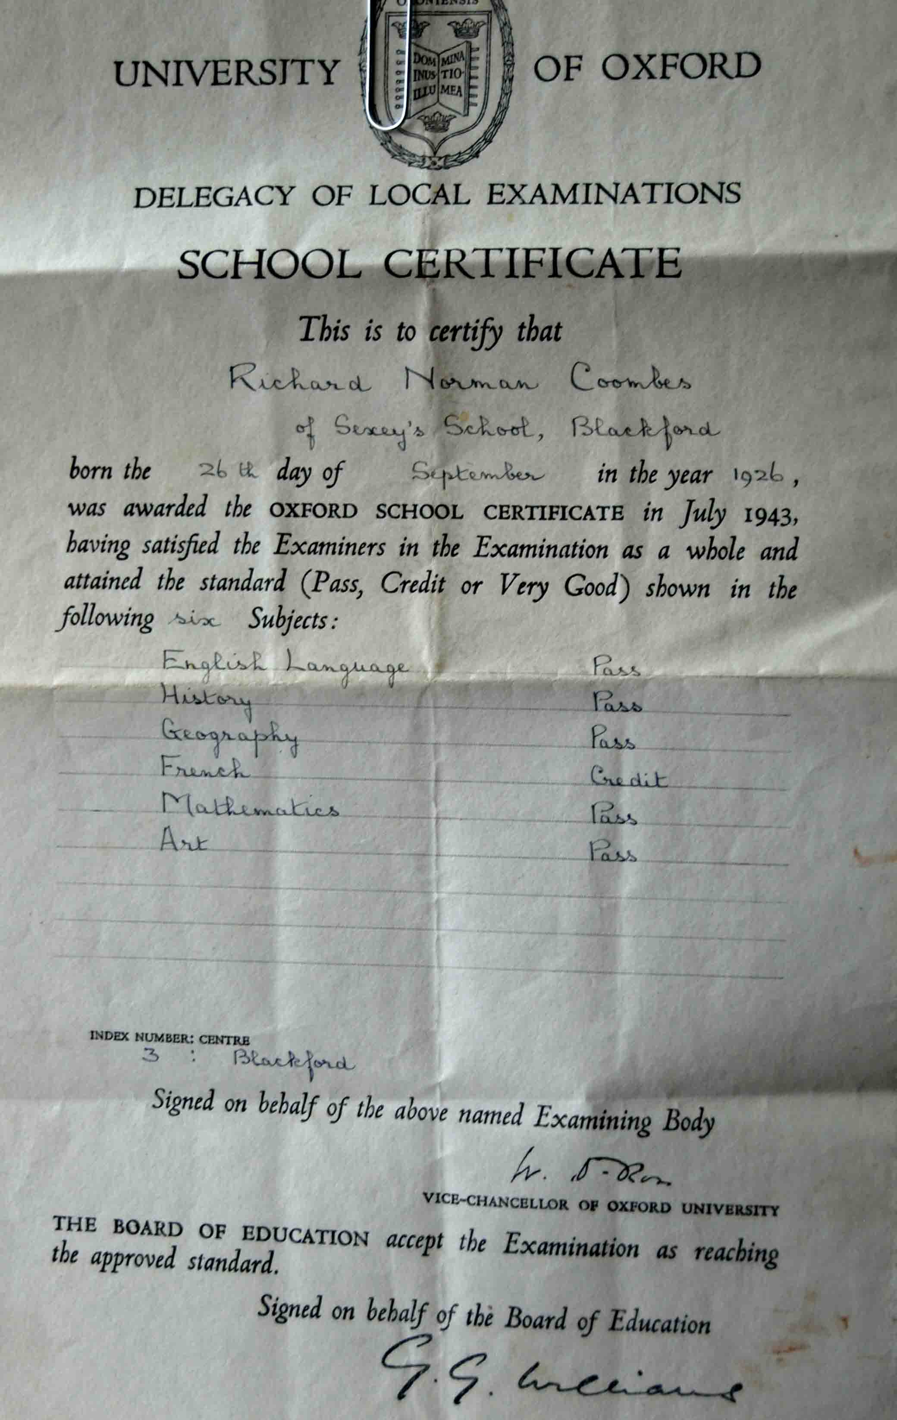

**When Richard finished Sexey's he worked in the admin department for British Rail and he remains an ardent 'steam buff' to this very day. (Richard, many thanks for allowing my wife and I to come to your home to talk about your school days - MJ)**

[**Back to the Top**](http://www.oldsexonians.com/page4.htm#top)

**If you have *any* memories/anecdotes/pictures from this era, whether they're 1st, 2nd or 3rd hand, please send them in to**

[**oldsexonians@hotmail.co.uk**](mailto:oldsexonians@hotmail.co.uk)